

SCSR2213 NETWORK COMMUNICATIONS
Task#3
CHOOSING THE APPROPRIATE LAN DEVICES

Group 4: Linux
SECTION: 5
Lecturer: Dr. Adnan Khalid

Name | Matric Number
Garrah Thabit Mohammed | A24CS4013
Mohammed Abdulrahim | A24CS4026
LEE TUNG ERN | A24CS0103
MOHAMMED ALSAKKAF | A23CS4026

Table Of Contents:
1. Introduction 3
2.Table of devices 5
3. Reflactions 14
4. Meeting Minutes 35
5. Refernces 9


Introduction
In the previous tasks, we laid a solid foundation for our project. In Task 1, we formed our team, "Linux", and designed a detailed floor plan for the new two-story Faculty of Computing building. We also documented our initial discussions in clear meeting minutes.
In Task 2, we conducted a preliminary analysis by crafting over 10 targeted questions to clarify the requirements and gather insights. Through research and consultations, we identified the current and future needs of the project, evaluated its feasibility, and updated our design plan where necessary to align with stakeholder expectations.
Now, with these two steps completed, Task 3 focuses on selecting the appropriate LAN devices with careful consideration of the given budget. This step involves identifying and justifying the network equipment that will meet the objectives of the case study. It is crucial to ensure that the new building is equipped with an efficient and secure network infrastructure to support both current and future demands.
After much research and considering the available resources, we agreed on selecting three brands for each of the network devices needed. The chosen devices are as follows:
- Printers:
A printer is a peripheral device that produces a durable representation of text or graphics, typically on paper. Various types of printers include 3D printers, inkjet printers, laser printers, and thermal printers.
- Copier:
A copier is a machine that makes copies of documents and other visual images onto paper or plastic film quickly and affordably. It is widely used in business, education, and government sectors.
- Smart TV:
A Smart TV is a traditional television set integrated with Internet connectivity and interactive Web 2.0 features, allowing users to stream music and videos, browse the web, and view photos. These devices combine computers, televisions, and digital media players, offering access to over-the-top media services like streaming TV and internet radio, along with network access.
- Routers:
A router is a network device that forwards data packets between computer networks. It connects one or more packet-switched networks or subnetworks, managing traffic between them and enabling multiple devices to share an Internet connection.
- Switches:
A switch is a network device that segments a local area network (LAN) into smaller segments. It improves network efficiency by directing traffic only to the intended device based on its MAC address. Switches support unicast, multicast, and broadcast communication within a single LAN segment.
- Desktop Tower:
A desktop tower is the main unit of a desktop computer, housing essential components such as the CPU, GPU, motherboard, RAM, storage, and power supply in a vertical case. It does not include peripherals like the monitor, keyboard, or mouse.
- Monitor:
A computer monitor is an output device that displays information in either pictorial or textual form. A monitor includes a visual display, supporting electronics, a power supply, housing, electrical connectors, and external user controls.
- Server:
A server is a device that provides functionality for clients, which are other programs or devices. Servers offer various services such as sharing data or resources among multiple clients or performing computations for clients.
- Cables:
Communication cables are used to interconnect devices like computers, routers, switches, and storage area networks. These cables are the medium through which data flows across the network.
- Fiber Optic Cables:
Fiber optic cables are high-speed communication cables that transmit data as light signals through thin strands of glass or plastic. They provide faster data transfer, greater bandwidth, and resistance to electromagnetic interference, making them ideal for long-distance and high-performance networking applications.
- Firewalls:
A hardware firewall is a network security solution designed to protect devices from malicious software and hardware attacks. It ensures that all traffic crosses the firewall for inspection, applying access controls and security policies to block unwanted traffic.
- Modems:
A modem is a device that connects a computer or network to the internet by converting digital signals into analog signals. It acts as a bridge between devices and an Internet Service Provider (ISP), enabling communication over telephone lines or mobile networks.
- Wireless Access Points:
A wireless access point (WAP) is a device that allows laptops, smartphones, and tablets to connect to a wired network via Wi-Fi. It serves as a hub for transmitting and receiving wireless signals, expanding network coverage in larger spaces.
- Patch Panels:
A patch panel is a hardware device used to organize and manage multiple cable connections, such as those between computers, servers, and switches. It provides a structured way to route and reroute network connections without handling individual cables directly, improving network organization and simplifying troubleshooting.

Table of Devices
Devices | Description | Price per unit  (RM) | quantity | total price  (RM)
1. Printer  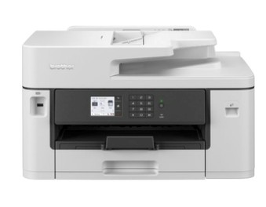 | Fast Printing  With an impressive First Print Out Time (FPOT) of 4.4 seconds, 28 ipm( image per minute) for black and 28 ipm for colour, you spend less time waiting for prints, and more | 1099 | 2 | 2198

Brother A4 +  A3 Ink Tank  MFC-J2340DW | time crafting your ideas.  High Volume, Cost Efficient  Experience the versatile print formats with volumes at an incredibly cost efficient yield. With Brother’s high-yield InkBenefit cartridges, get yields up to 3,000 pages for black and 1,500 pages for colour. Cost has never been more efficient.  Vivid Professional  Prints Great ideas materialise with quality prints. The new fast-drying pigment-based ink delivers superior print quality with high black density and true-to-life colours, ensuring each copy stays crisp, sharp and vivid.
2. Copier  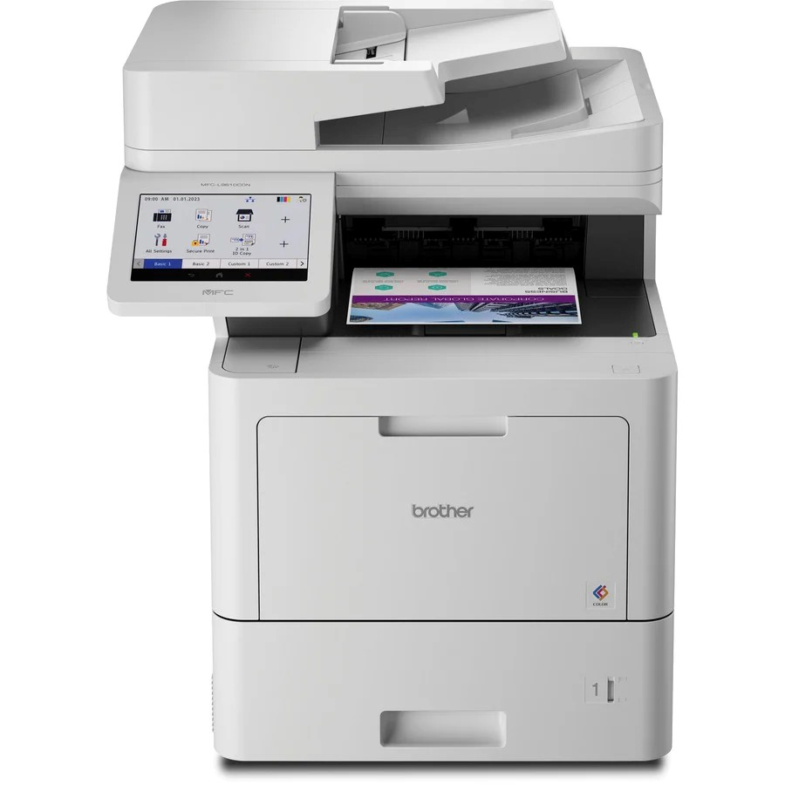  Brother MFC  L9610CDN  Color Laser  All-in-One  Copier | Fast business color printing  Provides the fastest color laser print speeds ever from Brother – up to 42 ppm( page per minute) to help increase workgroup productivity.  Create professional business documents. Features the boldest laser color output ever from Brother with vivid color and sharp black output for the professional results your reports, brochures, presentations, and other important business documents require.  Lifetime value. Offers built‐in value with included Brother Genuine 6,500‐page black and 5,000‐page color toner cartridges. For even lower cost printing, use Brother Genuine TN810XL high‐yield replacement toner cartridges for 12,000 pages black and 9,000 pages color.  Fast, high‐volume scanning with | 6594 | 3 | 19782

advanced capabilities. The 100‐page capacity auto document feeder boasts duplex scan speeds up to 104ipm. Scan to popular destinations directly from the touchscreen display including cloud services, email, SharePoint, SSH Server (SFTP), and more. Create searchable and editable Microsoft Office documents including Word, Excel, and PowerPoint. Offers advanced scanning features such as scan preview, auto deskew, continuous scanning, blank page skip, and more.
Large, scalable paper handling. Spend less time refilling paper trays with the
520‐sheet capacity paper tray and
100‐sheet capacity multipurpose tray. Total capacity is expandable up to 1,620 sheets with optional trays. An optional cabinet can be used to store paper and supplies and turn the printer into a floor‐standing configuration.
Flexible connectivity. Features built‐in Gigabit Ethernet networking to seamlessly set up and share on your wired network, with the availability of an optional dual band (2.4GHz / 5GHz) wireless module (NC‐9000W). Easily print from and scan to a wide variety of mobile devices.
3. Smart TV  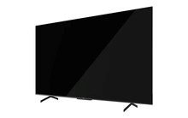  PRISM+ Q75  Ultra | The Q-Ultra Series, powered by Dolby Vision, HDR10+ and Filmmaker mode, makes for a cinematic experience like none other. Enjoy exceptional colors, contrast and lifelike details across the spectrum. Experience a total sound immersion with Dolby Atmos, a 3D spatial sound technology. | 4099 | 12 | 49188

4K UHD Definition
Expect ultra-crisp and sharp visuals down to every single pixel. See every detail in its most accurate and life-like form.
Far Field Voice Control
Control your TV, hands-free using just your voice, and nothing else. With in-built microphones, command it using Google Assistant by simply saying “Hey Google or Ok Google” – a true wireless experience.
Seamless Screencasting
Seamlessly cast photos, videos and music from your phone to the QLED screen for an even greater immersive experience without suffering from resolution loss.
Space-Optimizing Solutions
Save on space with a swivel or fixed mounts that bring added flexibility to your setup.
4. Routers  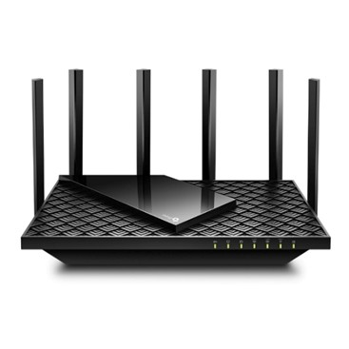  TP-Link  Archer AX75 | Super-Fast Tri-Band WiFi Up to 5.4 Gbps 2402 Mbps (5 GHz) + 2402 Mbps (5 GHz) + 574 Mbps (2.4 GHz)  Connect More, Stay Fast - OFDMA and MU-MIMO deliver data to multiple devices simultaneously, expanding the available bandwidth  Broad Coverage - 6× high-performance antennas, Beamforming, and high-power FEM combine to ensure vast coverage  Powerful Quad-Core Processing - Equipped with a 1.7 GHz Quad-Core CPU to handle huge throughput and eradicate latency | 970 | 4 | 3880
5. Switches | 250 W PoE Budget: 24×  802.3at/af-compliant PoE+ ports with a total | 1799 | 8 | 14392

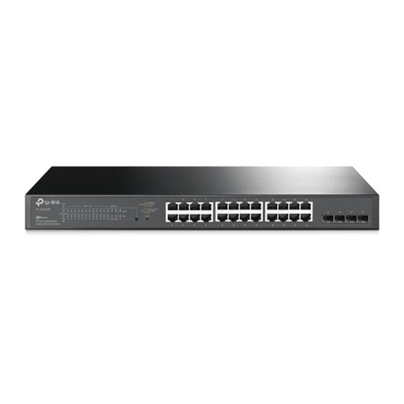  TP-Link TL-SG2428P | power supply of 250 W*.  Full Gigabit Ports: 24× gigabit PoE+ ports and 4× gigabit SFP Slots provide high-speed connections.  Integrated into Omada SDN: Zero-Touch  Provisioning (ZTP)**, Centralized Cloud Management, and Intelligent Monitoring.  Centralized Management: Cloud access and Omada app for ultra convenience and easy management.  Static Routing: Helps route internal traffic for more efficient use of network resources.  IPv6: IPv6 support with dual IPv4/IPv6 stack, MLD snooping, IPv6 neighbor discovery.
6. Desktop tower  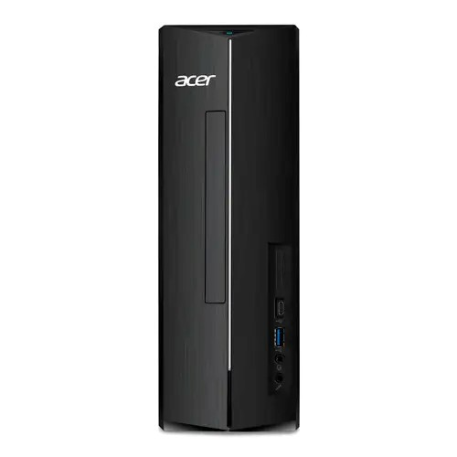  Acer Consumer  Desktop |  Aspire XC  Series XC-1785 | Operating System: Windows 11 Home  Processor: Intel® Core™ i5-14400  Graphics: Intel® UHD Graphics  Memory: 16 GB DDR5 (upgradable to 32 GB)  Storage: 1 TB PCIe Gen4 SSD  Ports:  Front: Card reader, 2 USB 3.2 Gen 1 Type  A, 1 USB 3.2 Gen 1 Type C, 2 audio jacks  Rear: 4 USB 2.0 Type A, 1 USB 3.2 Gen 1 Type A, 2 HDMI, LAN port, 3 audio jacks  Wireless: Wi-Fi 6 | 3299 | 172 | 567428
7. Monitor  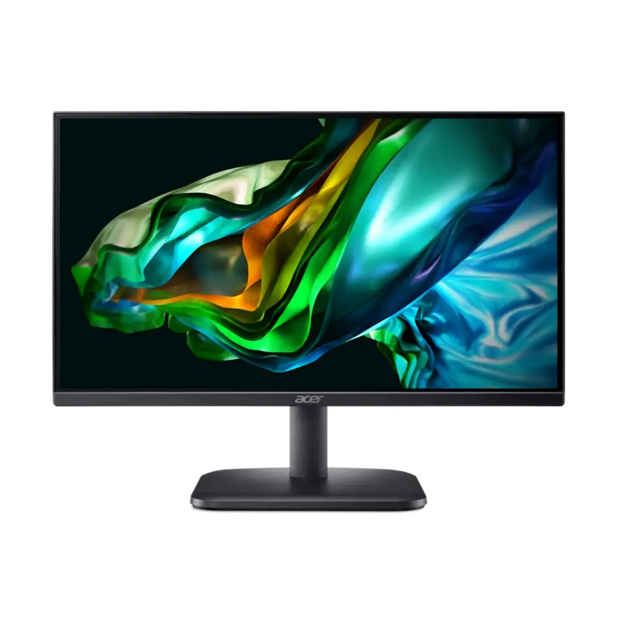  Acer Monitor - | Resolution: 1920 x 1080 (Full HD)  Refresh Rate: 100Hz  Response Time: 1ms (VRB)  Colour Gamut: 99% sRGB | 289 | 172 | 49708

Mainstream  Series - Work &  Play| EK221Q  H | Panel Type: VA (Vertical Alignment)  Brightness: 250 cd/m²  Contrast Ratio: 3000:1  AMD FreeSync: Yes (HDMI VRR)  Speakers: Yes (2 x 2W)
8. Server  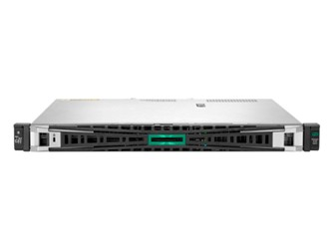  HPE ProLiant  DL20 Gen11  Rack Server  (E-2434.16GB.1T  B) | Processor(s): Intel® Xeon® E-2434 (4-Core,  3.4 GHz, 55W)  Memory: 16 GB UDIMM DDR5 4800 MT/s (1x 16 GB)  Hard Disk: HPE 1TB SATA 7.2K LFF LP HDD  Storage Controller: Embedded Intel® VROC SATA software RAID  Network Controller: HPE embedded 1Gb 4-port BCM5719 network adapter  Optical: HPE 9.5mm SATA DVD-ROM  Optical Drive  Power Supply: (1) 290W Non-redundant  Power Supply | 9883 | 1 | 9883
9. Ethernet Cables  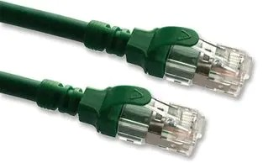  cat 6a  (2996AS-5G) by Videk | Patch Lead  RJ45 Plug to RJ45 Plug  SFTP  Double shielded for protection against  EM and RF interference  Low crosstalk  10Gbps CAT-6a standard for high demand applications  UL94V-2 Plug housing flammability | 70.1/5 m | 400 | 28040
10. Fiber  Optic Cables | Fiber Optic Cable | 652.88/ 100m | 2 | 1305.76

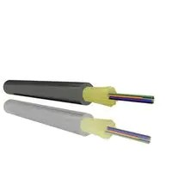  Fiber Optic  (MP007797) by MULTICOMP  PRO | OS2 Singlemode  8 Fibres  6 mm  328 ft  100 m
11. Firewalls  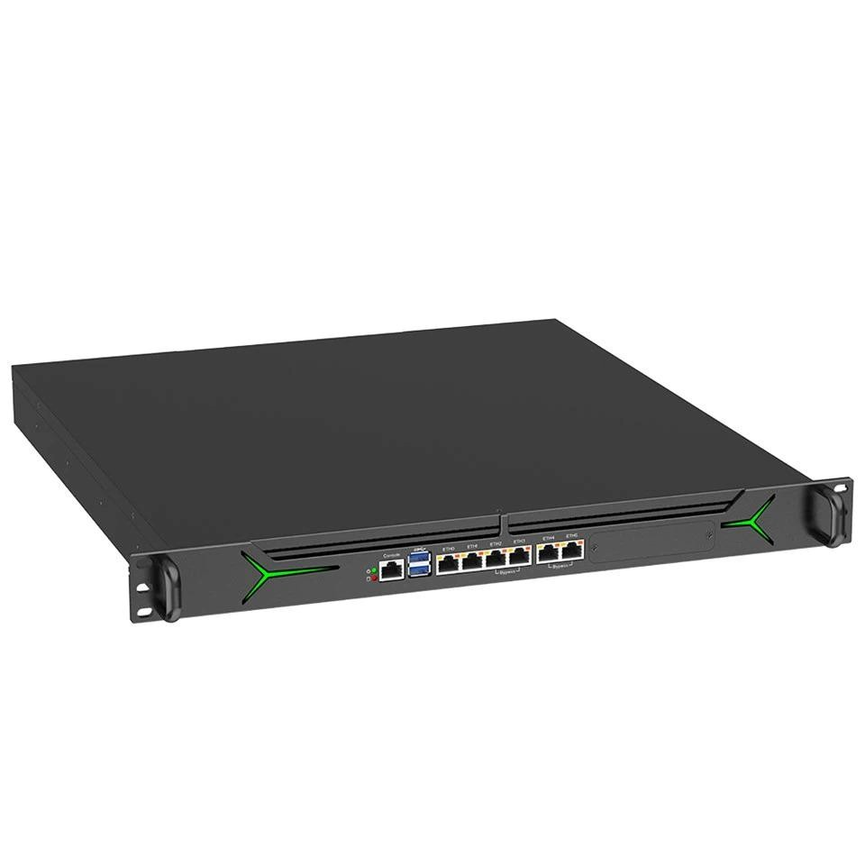  1U Rack Mount  Firewall  Appliance | Intel Quad-Core processor for high-performance routing and firewall tasks.  Up to 6 Gigabit Ethernet ports for flexible and scalable networks.  Supports up to 8 GB DDR4 RAM for  smooth handling of resource-heavy tasks like IDS/IPS and VPNs.  Offers storage options (SSD or HDD) for logs, backups, and configurations.  Compact 1U rack-mountable design, ideal for data centers and enterprise setups.  Advanced cooling system for reliable performance under heavy workloads. | 1200 | 2 | 2400
12. modems  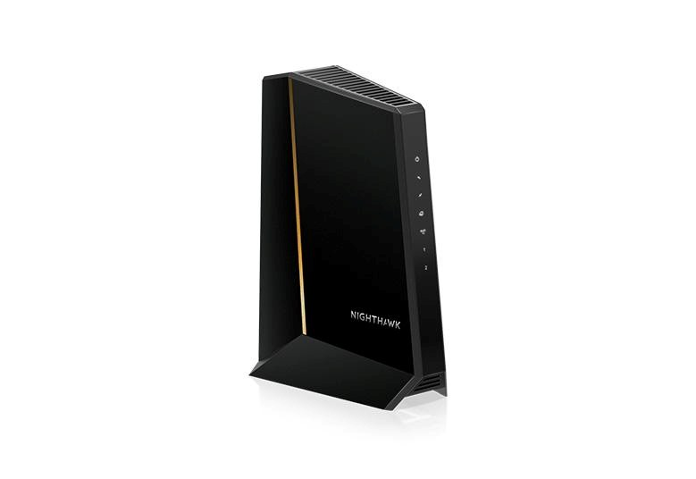  Nighthawk®Mi d/high-Split Multi-Gig  2.5Gbps Cable  Modem | Supports very fast 2.5Gbps internet speeds for quick connectivity.  Works with major internet providers like Xfinity, Spectrum, and Cox.  Uses DOCSIS 3.1 technology for reliable high-speed performance.  Has a multi-gig Ethernet port for easy connection to high-speed routers.  Compact design with good cooling for steady operation.  Great for future needs, supporting activities | 1300 | 2 | 2600

 | like 4K streaming.
13. wireless access point  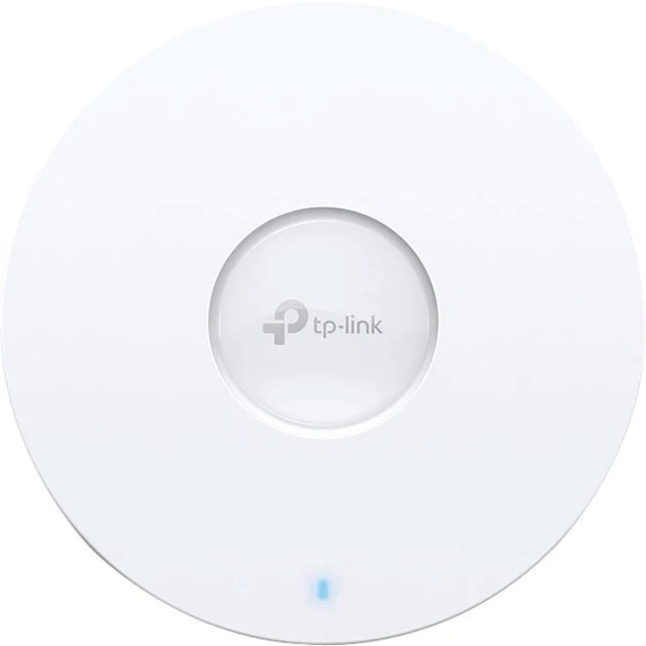  TP-Link  EAP653  AX3000 | Supports Wi-Fi 6 (802.11ax) technology with speeds up to 2976 Mbps (2402 Mbps on 5 GHz and 574 Mbps on 2.4 GHz).  Features MU-MIMO and OFDMA for  efficient multi-device handling, reducing latency and improving network performance.  Provides seamless roaming for uninterrupted connectivity while moving across the network.  Includes Power over Ethernet (PoE+) support for easy installation and reduced cable clutter.  Offers advanced security protocols, including WPA3, to protect user data and enhance network security.  Compact and sleek design for ceiling or wall mounting, suitable for offices, schools, and hospitality environments. | 580 | 14 | 8120
14. patch panel  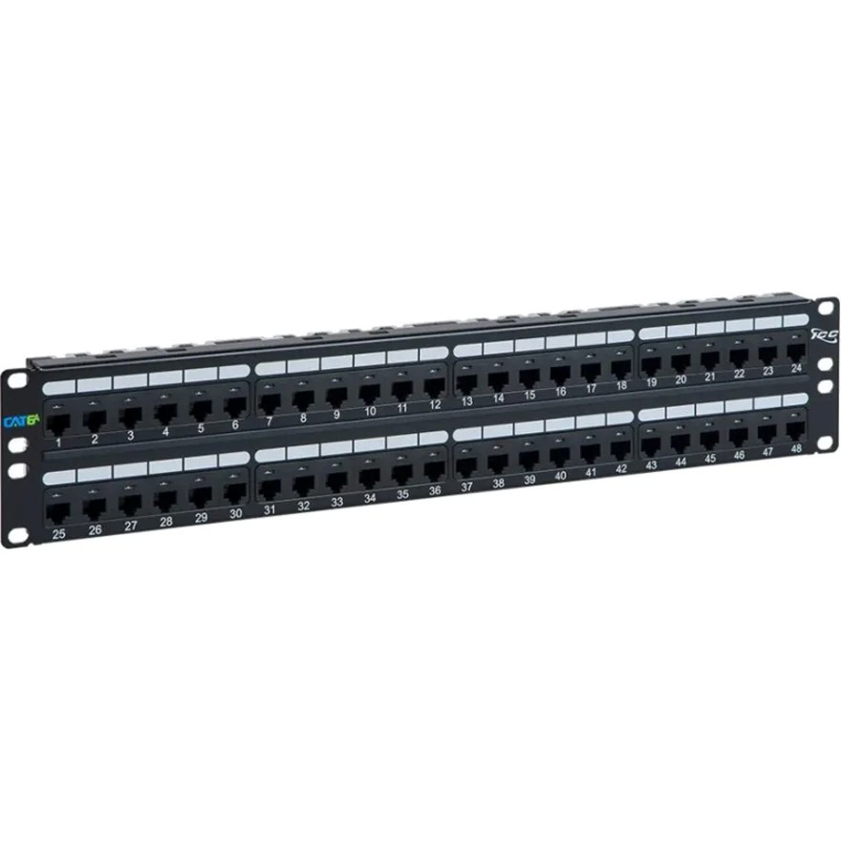  ICC Patch Panel,  CAT 6A, 48-Port,  2 RMS  (ICMPP0486B) | Has 48 RJ45 ports for connecting many devices with fast Cat6A Ethernet.  Supports 10 Gigabit Ethernet for reliable and quick data transfer.  Designed as a 2U rack-mount, fitting easily into standard 19-inch racks for a neat setup.  Comes with color-coded labels for easy wiring, making setup and maintenance simpler.  Made with a strong metal frame for durability in tough environments.  Ideal for large cabling projects in places | 1700 | 5 | 8500
 | like data centers and server rooms.
Total price |  |  |  | 767424.7  6

Reflections:
- Are you surprised by the prices? How were you surprised?

Yes, we were quite surprised by the price of RM 767,424.76, which constitutes a significant portion of our budget. We didn’t expect network devices and equipment to be so costly, especially since many of the items were not top models. Even basic items like cables added more to the overall cost than we anticipated. The total price was much higher than we had expected, showing us how quickly costs can accumulate.

- Have you ever considered cost as a factor for choosing networking devices?

Cost was not our primary concern when selecting networking devices. Our focus was on finding devices that met the needs of our project and ensuring the network would function effectively within our budget. We evaluated various options and chose the ones that provided the best balance of performance, value, and suitability for our project.
3- What are the major differences between the same devices from different brands? For example, Cisco and Huawei Routers.
1.Printer
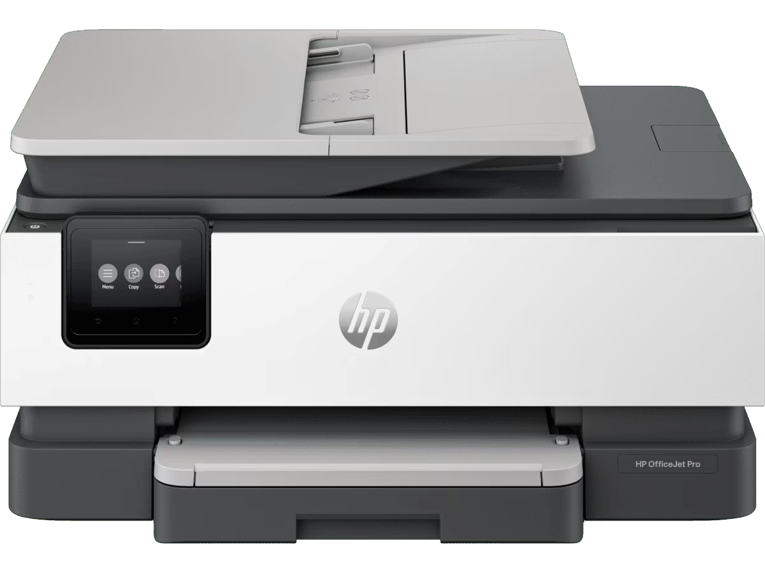  HP OfficeJet Pro 8120 All-in-One  Printer | 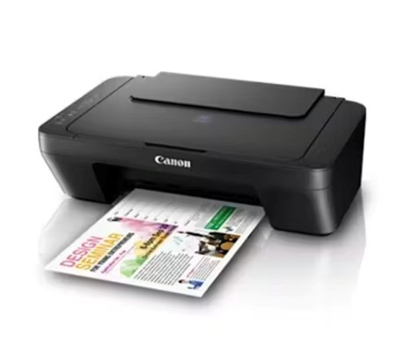  Canon Pixma E410 All-In-One  Printer | Brother A4 + A3 Ink Tank MFC-J2340DW
Speed:  - Black: Up to 20 ppm  (ISO)  - Color: Up to 10 ppm  (ISO)  - Draft Mode: Up to 29 ppm (black), 25 ppm  (color)  Duplex Printing: Automatic  (standard)  Wireless Capability: Yes, with  dual-band Wi-Fi (802.11 a/b/g/n/ac)  Monthly Page Volume: Up to  800 pages  Cartridges: 4 (Black, Cyan,  Magenta, Yellow)  Scan Resolution: Up to 1200 x 1200 dpi (optical)  Additional Features:  Touchscreen, Quiet mode, Mobile printing via HP Smart, AirPrint, Mopria, etc. | Print Speed:  - Mono: 8 ipm  - Color: 4 ipm  Duplex Printing: Manual  Wireless Capability: Yes (via USB 2.0)  Monthly Page Volume: 200  Cartridges: 2 (PG-47 Black,  CL-57S Color) with an optional  CL-57 cartridge  Scan Resolution: Up to 600 x 1200 dpi (optical)  Additional Features: Quiet  Mode, Mobile printing support (AirPrint, Canon print app),  48-bit color depth for scanning | Print Speed:  - Mono/Color: 28 ipm  - First Print Out Time  (FPOT): 4.4 seconds  (Mono), 4.6 seconds  (Color)  Duplex Printing: Automatic  Wireless Capability: Yes (IEEE 802.11b/g/n)  Monthly Page Volume: 1200 pages  Cartridges: 1 (Black) and 1  (Color)  Scan Resolution: Up to 600 x 600 dpi (optical)  Additional Features: Color copying, high print resolution  (up to 1200 x 4800 dpi), ADF  (up to 50 sheets)
RM 786 | RM219 | RM 1099

We have chosen the Brother A4 + A3 Ink Tank MFC-J2340DW primarily due to its high-speed printing capabilities, which make it an optimal choice for high-volume office environments. This printer is capable of handling a higher monthly page volume compared to other models, ensuring it can meet the demands of substantial paper handling. While the HP OfficeJet Pro 8120 All-in-One Printer offers superior print quality, the primary consideration for our office needs is print speed, making the Brother printer a more suitable option. In contrast, the Canon Pixma E410 All-In-One Printer is a more affordable choice but is not ideal for our requirements as it is unable to efficiently handle large printing volumes.

- Copier
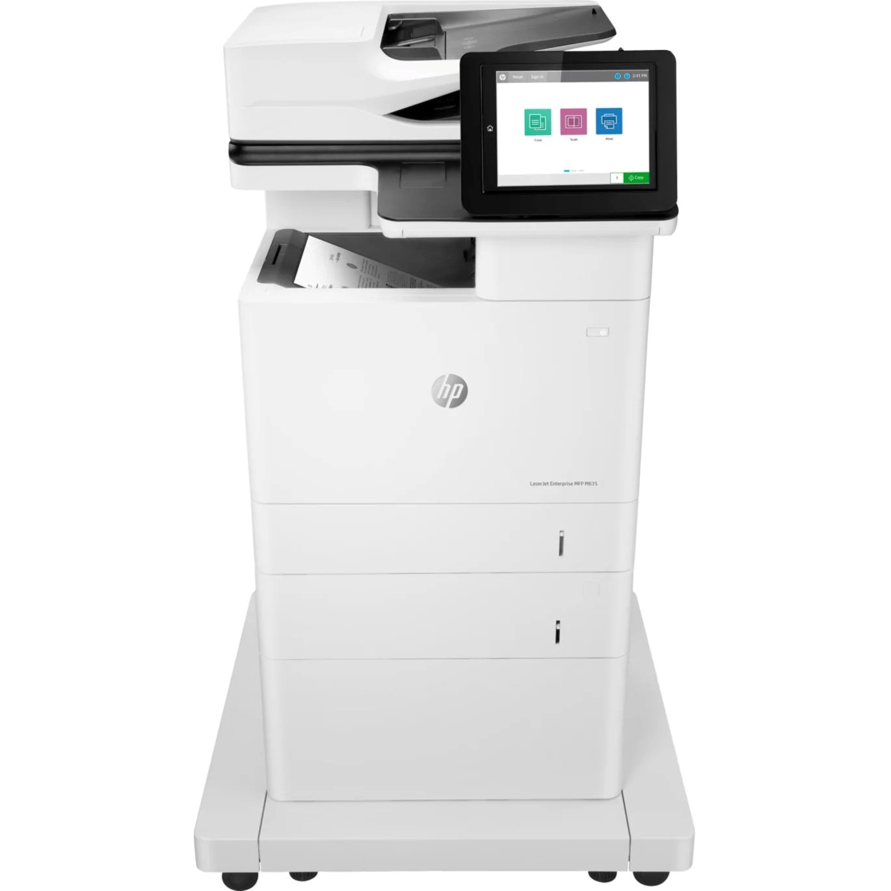  HP LaserJet M635fht Laser  Multifunction  Printer-Monochrome-Copier | 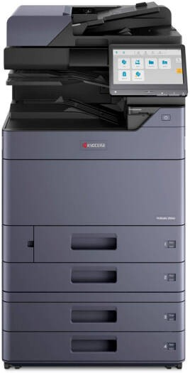  Kyocera TASKalfa 2554ci  Printer | Brother MFC L9610CDN Color  Laser All-in-One Copier
Type: Laser Multifunction  Printer  (Copier/Fax/Printer/Scanner)  Print Speed: 65 ppm  (monochrome)  Print Resolution: 1200 x 1200 dpi  Duplex Printing: Automatic Scanner: Flatbed, 600 dpi optical resolution, Color scanning  Copier: Monochrome, Flatbed  Fax: Monochrome, G3 Fax | Type: Color Multifunction  Printer  (Copier/Fax/Printer/Scanner) Print Speed: 25 ppm (color & monochrome)  Print Resolution: 1200 x 1200 dpi (print), 600 x 600 dpi (scan) Duplex Printing: Standard  Scanner: Flatbed and Document  Feeder, 600 dpi resolution,  Color scanning  Copier: Color & Monochrome,  Multiple copy features (Zoom,  Electronic Sort, etc.)  Fax: G3 Fax, 33.6 Kbps modem speed, 3-second transmission speed  Media Handling: 2 x 500-sheet | Type: Color Laser  Multifunction Printer  (Copier/Fax/Printer/Scanner)  Print Speed: 42 ppm  (monochrome and color) Print Resolution: 2400 x 600 dpi  Duplex Printing: Automatic  Scanner: Flatbed/ADF, 600 x 600 dpi optical resolution, Color  scanning  Copier: Color, Flatbed  Fax: Color, Flatbed
Media Handling: 1200-sheet capacity (combined input and output trays)  Monthly Duty Cycle: 300,000 pages  Recommended Monthly Print  Volume: 5,000 to 30,000 pages Key Features: High print speed, large input capacity, and high monthly duty cycle.  . | input trays, 150-sheet  multipurpose tray, 100-sheet  ADF  Monthly Duty Cycle: 80,000 pages  Recommended Monthly Print  Volume: 10,000 to 25,000 pages Key Features: Compact design with high-quality color printing and advanced copy features | Media Handling: 520-sheet input tray, 100-sheet ADF, and 100-sheet multipurpose tray Monthly Duty Cycle: 120,000 pages  Recommended Monthly Print  Volume: 12,000 pages  Key Features: High print quality and support for multiple wireless print technologies.
RM 18715 | RM16880.46 | RM 6594

We have selected the Brother MFC L9610CDN for its affordability relative to other alternatives, while still providing the essential features needed for faculty use. Its recommended monthly print volume of 12,000 pages is adequate to support the heavy printing demands within the faculty. While other options, such as the HP LaserJet M635fh and Kyocera TASKalfa 2554ci Printer, offer additional features and superior performance, the increased costs of these models—more than double the price of the Brother MFC L9610CDN—do not provide enough additional value to justify the higher price. As such, these alternatives are less budget-friendly for our needs..
- Smart Tv
PRISM+ Q75 Ultra | 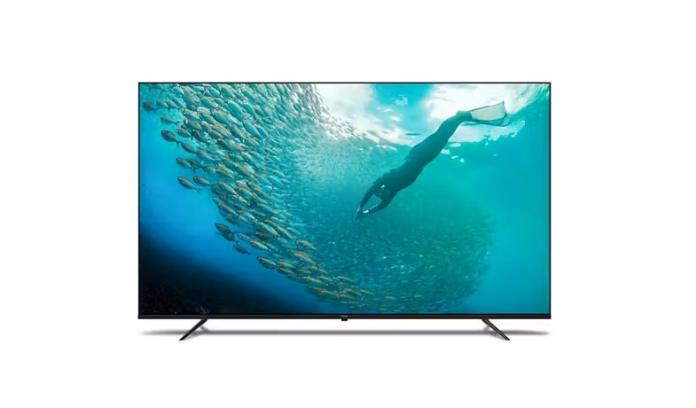  Philips 7100 Series 75-inch 4K  UHD LED TV | 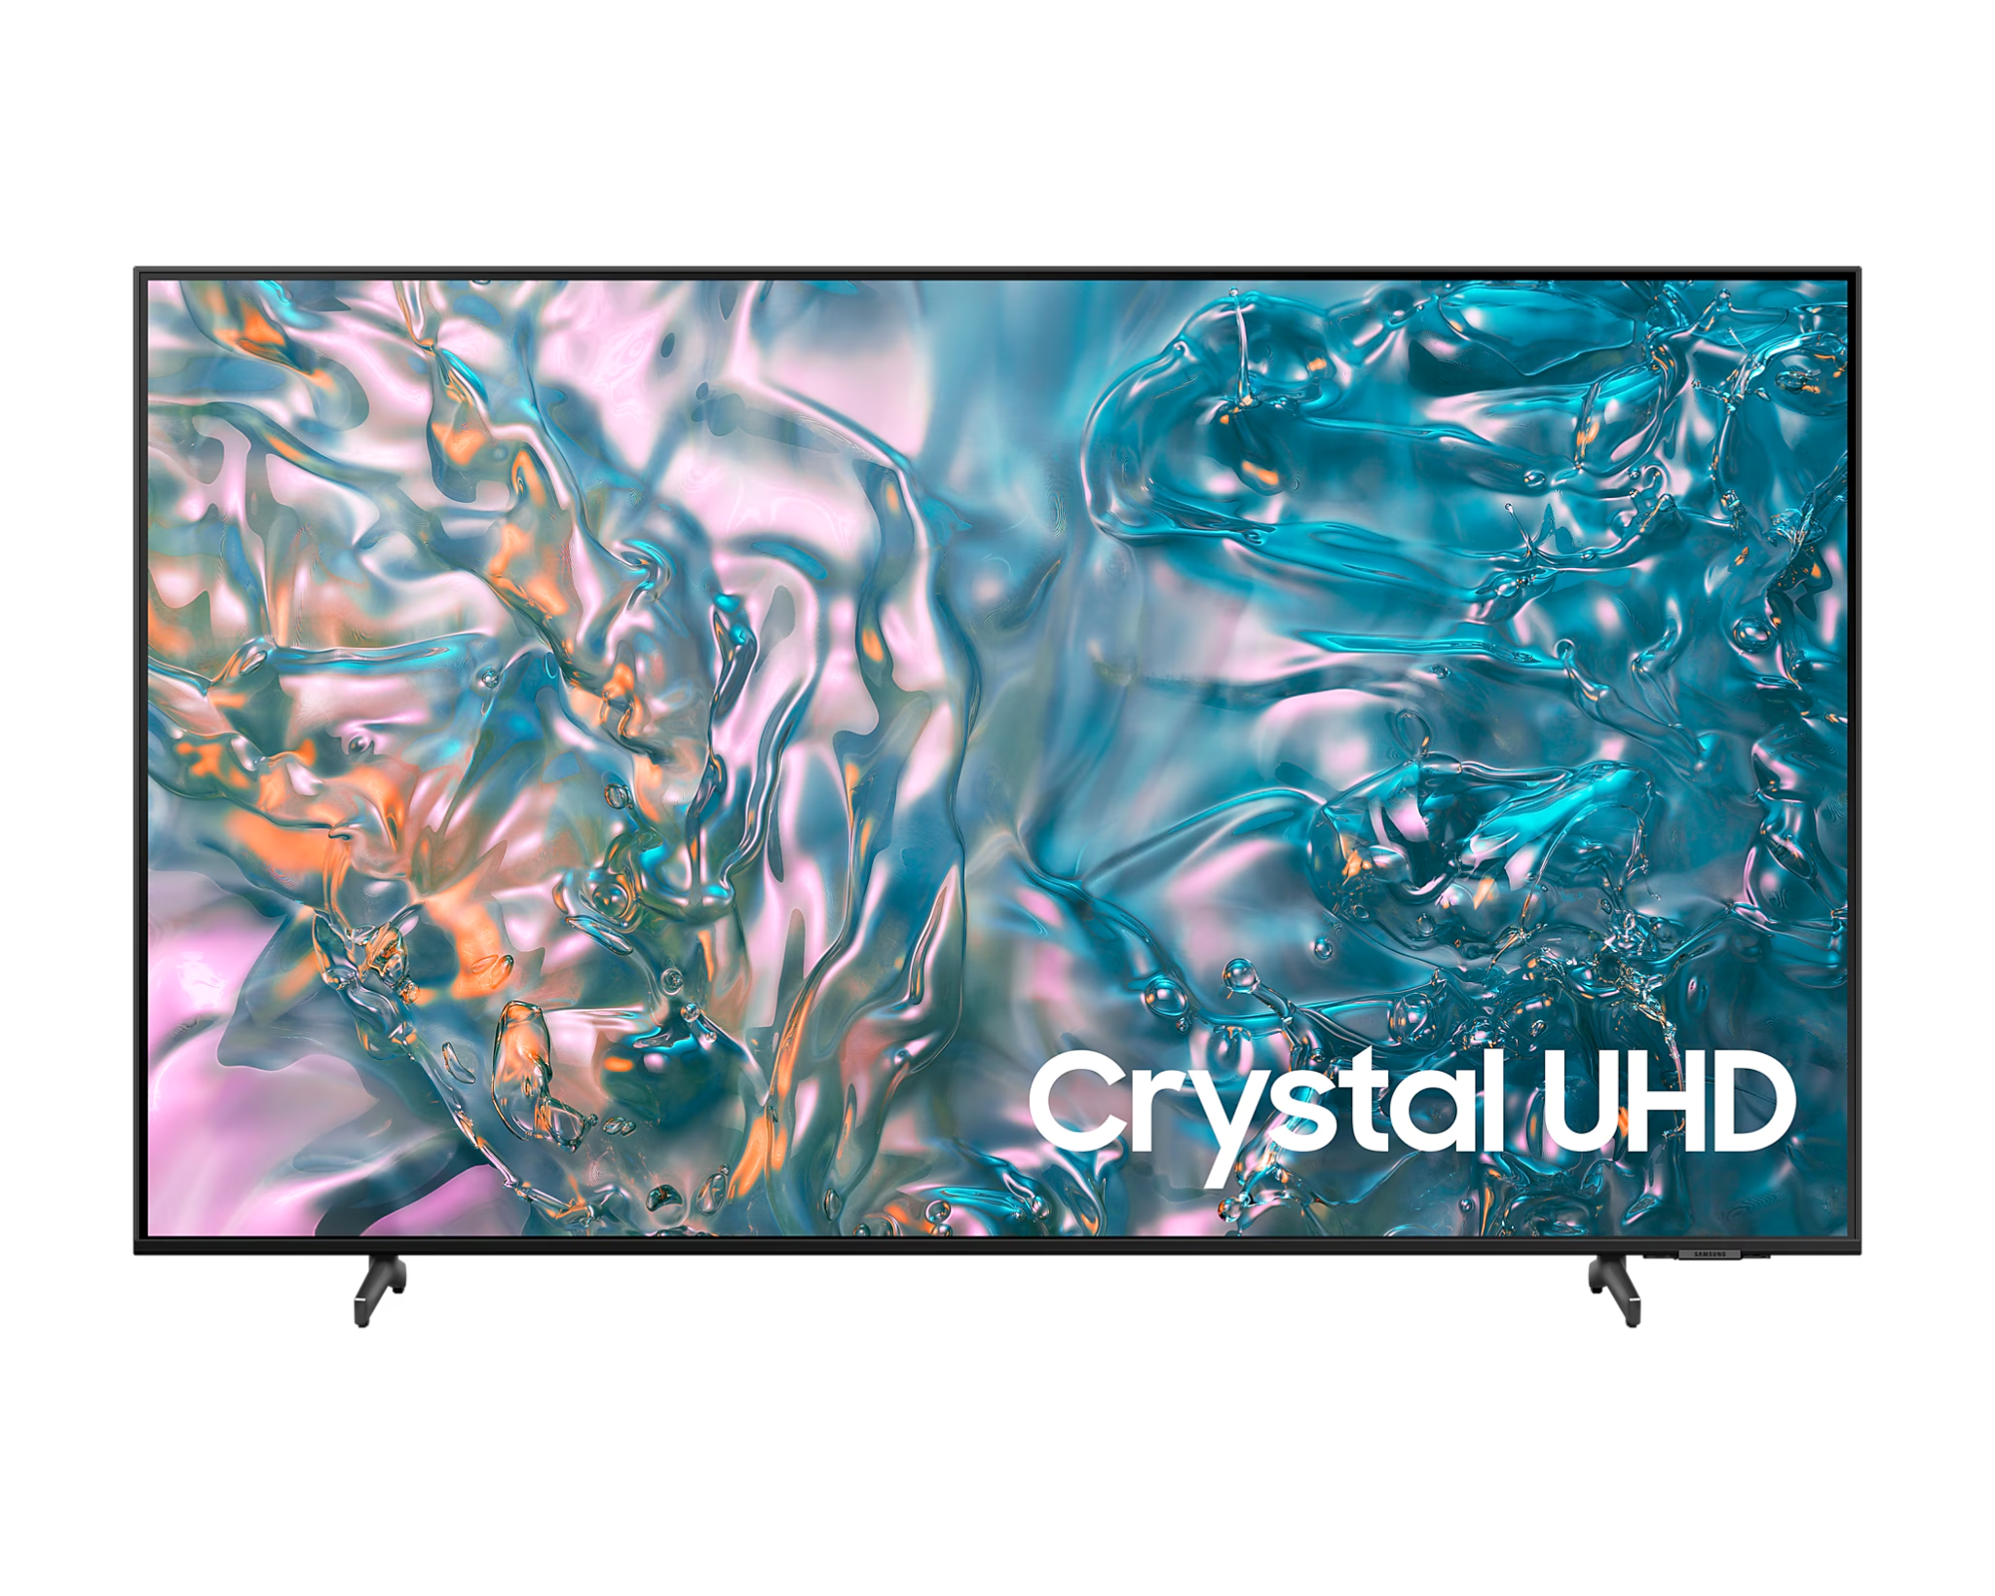  SAMSUNG 75" Crystal UHD DUE800 4K Smart TV
Panel Technology: QLED  Operating System: Google TV  Screen Size: 75"  Resolution: 4K (3840 x 2160)  Refresh Rate: 60Hz  HDR Support: HDR10+, Dolby  Vision  Dolby Atmos: Yes  Voice Control: Hands-free | Panel Technology: 4K Ultra HD  LED  Operating System: Google TV  Screen Size: 75"  Resolution: 4K (3840 x 2160)  Refresh Rate: Not specified  HDR Support: HDR10, Dolby  Vision, HLG  Dolby Atmos: Yes  Voice Control: Google Assistant | Panel Technology: LED  Operating System: Tizen™  Screen Size: 75"  Resolution: 4K (3840 x 2160)  Refresh Rate: 50Hz  HDR Support: HDR10+  Dolby Atmos: No  Voice Control: Bixby, Alexa,
Google Assistant  Connectivity Options: HDMI  2.0 (3), USB (2), Ethernet,  Optical Audio Out  Bluetooth Version: Bluetooth  5.1  Wall Mount VESA: 600 x 400 mm | with remote microphone Connectivity Options: HDMI  (3), USB (2), Ethernet, Optical  Audio Out  Bluetooth Version: Bluetooth  5.1  Wall Mount VESA: 500 x 300 mm | and Google Assistant support  Connectivity Options: HDMI  (3), USB (2), Ethernet, Optical  Audio Out  Bluetooth Version: Bluetooth  5.2  Wall Mount VESA: 400 x 400 mm
RM 4099 | RM 4399 | RM 4899

We have chosen the PRISM+ Q75 Ultra for its superior features, including its QLED panel, which provides vibrant colors, enhanced brightness, and wider viewing angles compared to the Philips 7100 Series 75-inch 4K UHD LED TV and the SAMSUNG 75" Crystal UHD DUE800 4K Smart TV. Another significant factor in our decision was its ease of use; the hands-free Google Assistant and Google TV functionalities make it particularly suitable for faculty use. Additionally, the PRISM+ Q75 Ultra is lighter and offers greater wall mount compatibility, making installation and maintenance simpler. Lastly, it is the most cost-effective option among the three, providing excellent value for money.

4-Routers:
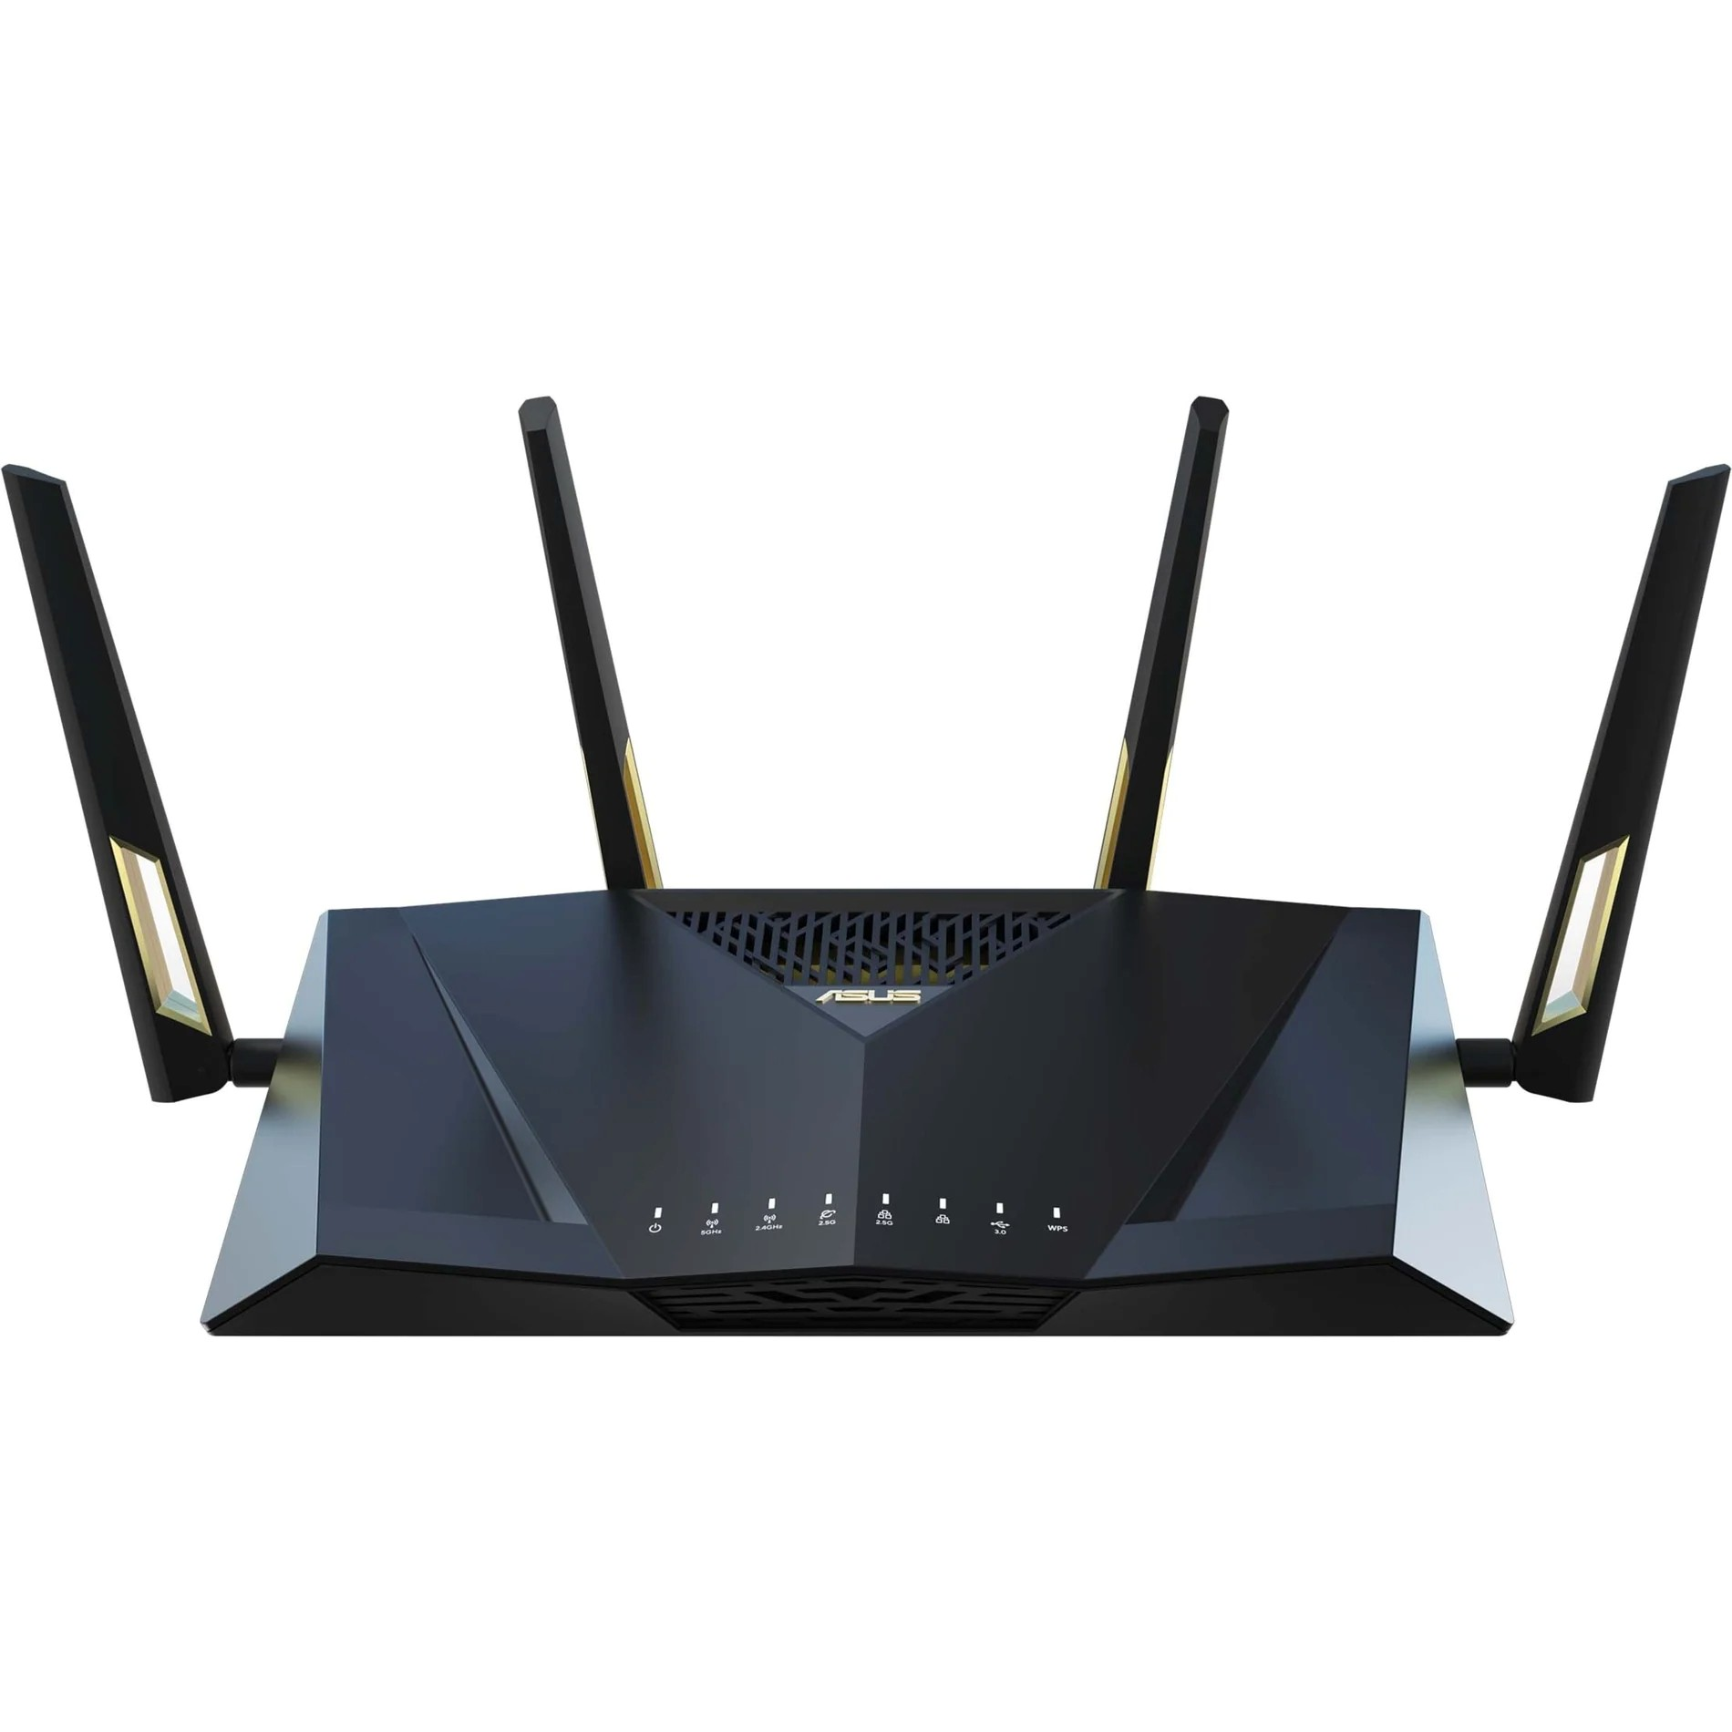  ASUS RT-AX88U Pro |  |  | 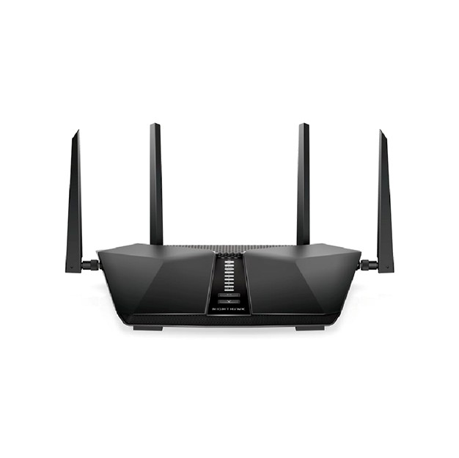  Netgear RAX50 | TP-Link Archer AX75
- Wi-Fi 6 technology for faster and more reliable wireless connections  - Dual-band network band for enhanced network performance |  | ●  ● | UP TO 5.4GBPS  SPEEDS—600+4800Mbps  with 6-stream connectivity**  160MHZ CHANNEL SUPPORT***—Enjoy greater than 1Gbps WiFi speeds for blazing fast | - Super-Fast Tri-Band WiFi Up to 5.4 Gbps - 2402  Mbps (5 GHz) + 2402 Mbps  (5 GHz) + 574 Mbps (2.4 GHz)  - Connect More, Stay Fast OFDMA and MU-MIMO
●  ●  ●  ●  ●  ●  ●  ● | Supports virtual assistant Alexa for voice control and convenience  Gigabit Ethernet technology for high-speed wired connections  USB port for easy file sharing and device connectivity  5 network (RJ-45) ports and 1 broadband (RJ-45) port for versatile network setup  WPA3 and WPS encryption  standards for secure wireless communication  Wi-Fi mesh system support for seamless coverage throughout your home  4 external antennas for extended wireless range  Total wireless transmission speed of 744 MB/s for smooth streaming and gaming | ●  ●  ● | streaming and downloading to newer mobile devices  SUPERSPEED USB 3.0 PORT —Up to 10x faster than USB 2.0  5 GIGABIT  PORTS—Connect more  wired devices for faster file transfer and uninterrupted  connections with 1 WAN & 4 LAN Ethernet ports  1024-QAM—25% increased data efficiency and faster  speeds than a 256-QAM  router | ●  ● | deliver data to multiple devices simultaneously, expanding the available bandwidth  Broad Coverage - 6×  high-performance antennas, Beamforming, and high-power FEM combine to ensure vast coverage  Powerful Quad-Core  Processing - Equipped with a 1.7 GHz Quad-Core CPU to handle huge throughput and eradicate latency
 | RM1,488 |  | RM1,259.00 |  | RM970

We have selected the TP-Link Archer AX75 due to its cost-effectiveness and its support for Wi-Fi 6 technology, offering speeds of up to 5.4Gbps. It is capable of managing multiple devices simultaneously through the use of MU-MIMO and OFDMA technologies. Additionally, its six antennas and tri-band support ensure reliable performance in high-traffic areas. The router will primarily serve for routing and redundancy purposes, with access points handling the majority of wireless connectivity needs.

5-Switches:
 | 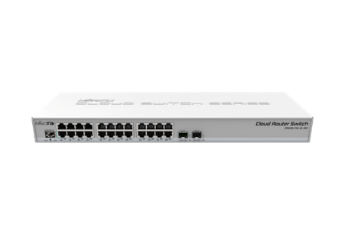 | 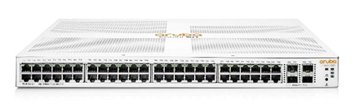  Aruba Instant On 1930 48G
TP-Link TL-SG2428P | MikroTik CRS326-24G-2S+RM | 4SFP/SFP Switch JL685A
- 250 W PoE Budget: 24×  802.3at/af-compliant PoE+ ports with a total power supply of 250 W*.  - Full Gigabit Ports: 24× gigabit PoE+ ports and 4× gigabit SFP Slots provide high-speed connections.  - Integrated into Omada SDN: Zero-Touch Provisioning  (ZTP)**, Centralized Cloud Management, and Intelligent Monitoring.  - Centralized Management: Cloud access and Omada app for ultra convenience and easy management.  - Static Routing: Helps route internal traffic for more efficient use of network resources.  - IPv6: IPv6 support with dual IPv4/IPv6 stack, MLD snooping, IPv6 neighbor discovery. | - Non-blocking Layer 2  switching capacity  - 16K host table  - IEEE 802.1Q VLAN  - Supports up to 4K VLANs  - Port isolation  - Port security  - Broadcast storm control  - Access Control List  - Web-based GUI | - 48 Gigabit Ethernet ports and 4 SFP/SFP+ uplink ports for flexible and high-speed connectivity.  - Throughput capacity (Mpps)  : 130.95 Mpps  - Switching capacity: 176  Gbps  - Reliability MTBF (years):  114  - Maximum power rating:  36.9W
RM1,799.00 | RM1,038.00 | RM2,909.99
We have chosen the TP-Link TL-SG2428P due to its 24 Gigabit PoE+ ports, 4 SFP uplink ports, and a 250W PoE budget, which provides sufficient power for access points and other devices. Unlike other switches that do not support PoE, the TL-SG2428P operates effectively with access points without the need for additional PoE injectors. While alternative models may offer more ports and higher switching capacity, their lack of a PoE budget and higher costs make them less practical for our needs.
6. Desktop
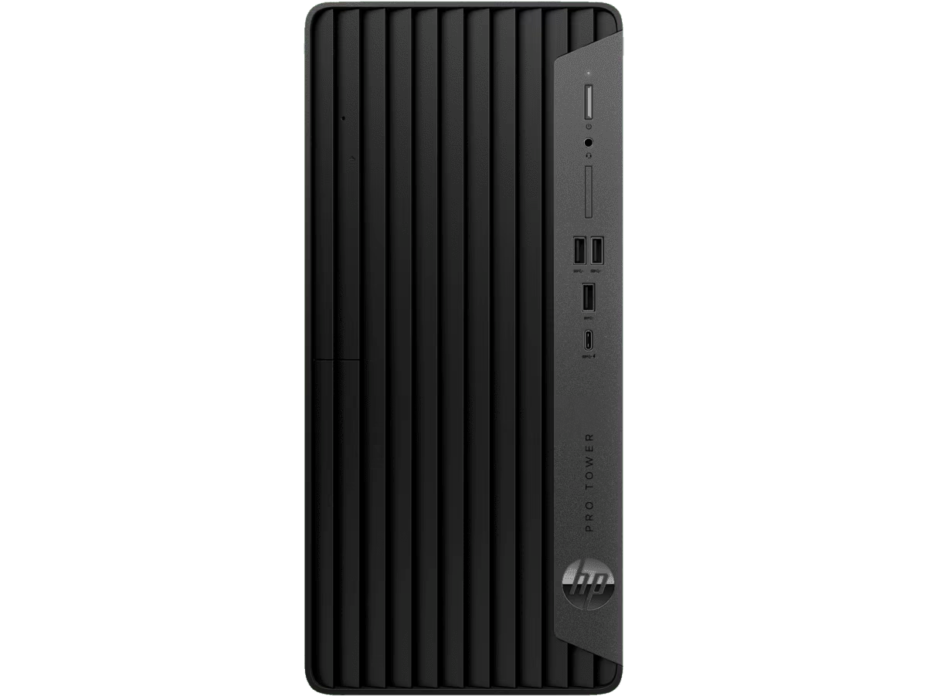  HP Pro Tower 400 G9 PCI Desktop PC | 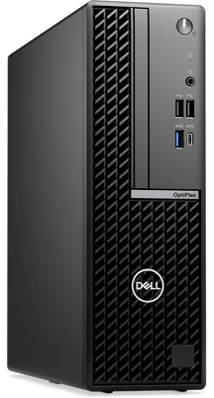  DELL OptiPlex Small Form  Factor | Acer Consumer Desktop |  Aspire XC Series - XC-1785
Operating System: Windows 11  Pro  Processor: Intel® Core™ i5-14500 (up to 5.0 GHz, 24 MB L3 cache, 14 cores, 20  threads)  Graphics: Intel® UHD Graphics  770  Memory: 8 GB RAM Storage: 512 GB SSD  Ports:  1 headphone/microphone combo  1 SuperSpeed USB Type-C®  (10Gbps)  3 SuperSpeed USB Type-A  (10Gbps)  Security: HP Wolf Security  (hardware-enforced defense) | Operating System: Windows 11  Pro  Processor: Intel® Core™ i5-14500 vPro® (up to 5.0 GHz,  24MB cache, 14 cores, 20  threads)  Graphics: Intel® UHD Graphics  Memory: 16 GB DDR5 RAM  Storage: 512 GB PCIe NVMe SSD  Ports:  Front: 2 USB 2.0, 1 USB 3.2 Gen 1 (5 Gbps) Type-C®, 1 audio jack  Rear: 2 USB 2.0, 2 USB 3.2  Gen 1, 1 DisplayPort™, 1  HDMI 1.4b, 1 RJ45 Ethernet  Port  Wireless: No Wi-Fi LAN card | Operating System: Windows 11  Home  Processor: Intel® Core™ i5-14400  Graphics: Intel® UHD Graphics  Memory: 16 GB DDR5  (upgradable to 32 GB) Storage: 1 TB PCIe Gen4 SSD  Ports:  Front: Card reader, 2 USB 3.2  Gen 1 Type A, 1 USB 3.2 Gen 1  Type C, 2 audio jacks  Rear: 4 USB 2.0 Type A, 1 USB  3.2 Gen 1 Type A, 2 HDMI,  LAN port, 3 audio jacks  Wireless: Wi-Fi 6
RM 3637 | RM 3661.87 | RM 3299
We have selected the Acer Consumer Desktop | Aspire XC Series - XC-1785 primarily for its large storage capacity of 1TB SSD, which is essential for faculty use as it allows for the storage and access of a large number of documents by multiple students. The desktop also features 16GB DDR5 memory, which can be upgraded to 32GB, making it well-suited for software development tasks that require high memory capacity, such as working with emulators. Additionally, it supports Wi-Fi 6, ensuring improved wireless connectivity.
Although the processor of this desktop is slightly slower compared to other alternatives like the HP Pro Tower 400 G9 PCI Desktop PC and the DELL OptiPlex Small Form Factor, the performance difference is minimal as the processors are from the same generation. When considering factors such as storage and memory, the Acer desktop provides better value in the same price range. In conclusion, the Acer Consumer Desktop | Aspire XC Series - XC-1785 offers a balanced combination of components and performance, making it an excellent choice for its value for money.

7. Monitor
Acer Monitor - Mainstream  Series - Work & Play| EK221Q  H | 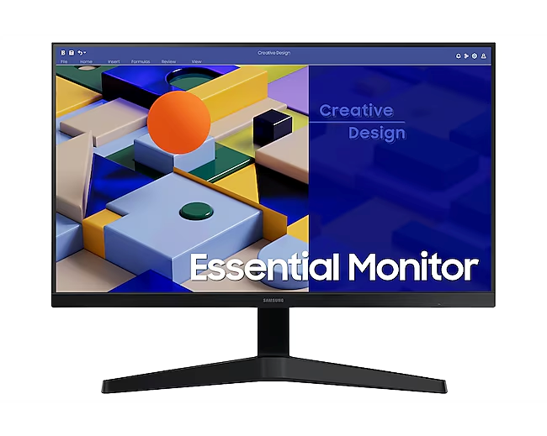  SAMSUNG 24" Essential Monitor S3 S31C FHD | 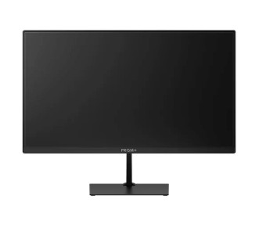  PRISM+ W220v
Resolution: 1920 x 1080 (Full  HD)  Refresh Rate: 100Hz  Response Time: 1ms (VRB)  Colour Gamut: 99% sRGB  Panel Type: VA (Vertical  Alignment)  Brightness: 250 cd/m²  Contrast Ratio: 3000:1  AMD FreeSync: Yes (HDMI  VRR)  Speakers: Yes (2 x 2W) | Resolution: 1920 x 1080 (Full  HD)  Refresh Rate: 75Hz  Response Time: 5ms (GTG)  Colour Gamut: 72% NTSC  Panel Type: IPS (In-Plane  Switching)  Brightness: 250 cd/m² (Typical)  Contrast Ratio: 1000:1 (Typical)  FreeSync: Yes  Speakers: No | Resolution: 1920 x 1080 (Full  HD)  Refresh Rate: 100Hz  Response Time: 12ms (GTG)  Colour Gamut: 95% sRGB  Panel Type: VA (Vertical  Alignment)  Brightness: 220 cd/m²  Contrast Ratio: 3000:1  FreeSync: Yes  Speakers: No
RM 289 | RM 399 | RM 349

After careful comparison with two other alternatives, we decided to choose the Acer EK221QH monitor. This model stood out for offering the fastest response time of 1ms, which is particularly advantageous for web development and design, as it ensures smooth performance and responsiveness. Additionally, it covers 99% of the sRGB color gamut, delivering vibrant and accurate colors that are essential for creative work. The inclusion of AMD FreeSync technology further enhances the visual experience by reducing screen tearing and stuttering. Notably, among the three options considered, this monitor also comes at the lowest price, making it a highly cost-effective choice without compromising on performance. Therefore, we concluded that the Acer EK221QH is the most suitable option for our needs.
8-Server:
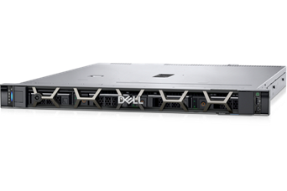  PowerEdge R250 Rack Server | HPE ProLiant DL20 Gen11 Rack Server (E-2434.16GB.1TB) | 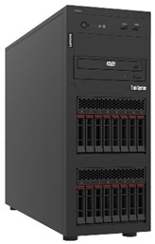  Lenovo ThinkSystem ST250 V2 7D8FS0Y400
- Chassis Configuration: 3.5"  Chassis with up to x4 Hot  Plug Hard Drives with  Backplane  - Processor: Intel® Xeon® E-2324G 3.1GHz, 8M  Cache, 4C/4T, Turbo (65W),  3200 MT/s  - Processor Thermal  Configuration: Heatsink for  80W or less CPU  - Memory Capacity: 16GB  UDIMM, 3200 MT/s, ECC  - RAID Configuration: C3,  RAID 1 for 2 HDDs or  SSDs (Matching  Type/Speed/Capacity)  - RAID/Internal Storage  Controllers: PERC H355  Adapter LP  - Hard Drives: 4TB Hard  Drive SAS ISE 12Gbps 7.2K  512n 3.5in Hot-Plug, AG  Drive | - Processor(s): Intel® Xeon®  E-2434 (4-Core, 3.4 GHz, 55W)  - Memory: 16 GB UDIMM  DDR5 4800 MT/s (1x 16 GB)  - Hard Disk: HPE 1TB SATA  7.2K LFF LP HDD  - Storage Controller: Embedded Intel® VROC SATA software  RAID  - Network Controller: HPE embedded 1Gb 4-port BCM5719 network adapter  - Optical: HPE 9.5mm SATA DVD-ROM Optical Drive  - Power Supply: (1) 290W  Non-redundant Power Supply | - Processor: Intel Xeon E-2334  Processor - 3.4GHz, 8M  Cache, 4 Cores  - Memory: 16GB TruDDR4  3200 MHz (2Rx8, 1.2V) ECC UDIMM  - Storage: 3.5" 1TB 7.2K SATA  6Gb Hot Swap 512n HDD  - Optical Drive: ThinkSystem  Half High SATA DVD-RW  Optical Disk Drive  - Hard Disk Chassis: 4x3.5" SATA/SAS Backplane  - RAID Controller :  ThinkSystem RAID 5350-8i  PCIe 12Gb Adapter (RAID 0, 1, 10, 5, 50)  - Network Controller: 2x 1GbE  Onboard Ethernet ports  (Broadcom BCM5720)
RM15,093.60 | RM9,883.00 | RM7,929.00

After evaluating the available options, we chose the HPE ProLiant DL20 Gen11 due to its well-rounded combination of performance, scalability, and cost-effectiveness. Although the Dell PowerEdge R250 offers superior specifications, its higher price makes it less practical for our needs. On the other hand, the Lenovo ThinkSystem ST250 V2, while more affordable, relies on DDR4 memory, which may limit future scalability. In contrast, the HPE ProLiant DL20 Gen11 supports DDR5 memory, ensuring better performance and future-proofing. Additionally, it features four network ports, providing redundancy and improved connectivity, and offers sufficient local storage, making it a balanced and reliable choice for our use case.
.
- Ethernet Cables:
cat 6a (2996AS-5G) by Videk | 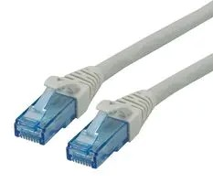  cat 6a (21.15.2709) by Roline | 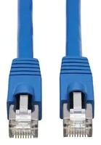  cat 6a (N261P-050-BL) by EATON TRIPP LITE
- Patch Lead  - RJ45 Plug to RJ45 Plug  - SFTP  - Double shielded for protection against EM and RF interference  - Low crosstalk  - 10Gbps CAT-6a standard for high demand applications  - UL94V-2 Plug housing  flammability | - RJ45 Plug to RJ45 Plug  - UTP | - RJ45 Plug to RJ45 Plug  - FUTP
RM70.1/5 m | RM190.27/20m | RM196.920/15.24m

We selected the Cat 6a (2996AS-5G) by Videk due to its high performance, affordable price, and superior shielding capabilities. This cable features double shielding (SFTP), which provides enhanced protection against both electromagnetic (EM) and radio frequency (RF) interference. Such shielding is particularly important in environments with high levels of electrical noise—like our faculty building, which contains laboratories, offices, and numerous connected devices. Given these factors, the Cat 6a (2996AS-5G) represents a reliable and cost-effective solution for our networking needs.

- Fiber Optic Cables:
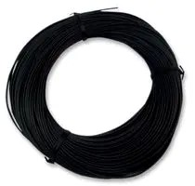  Fiber Optic (HFBR-RUS100Z) by BROADCOM | 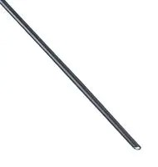  Fiber Optic (FDPF 4001 EH) by FIBRE DATA | Fiber Optic (MP007797) by  MULTICOMP PRO
- Fiber Optic Cable  - Singlemode  - 9µm / 125µm  - 8 Fibres  - 5.6 mm | - Fiber Optic Cable  - Singlemode  - 1mm  - 1 Fibres  - 2.2 mm  - 65 ft  - 20 m | - Fiber Optic Cable  - OS2 Singlemode  - 8 Fibres  - 6 mm  - 328 ft  - 100 m
RM744.580/100m | RM133.410/20m | RM652.880/100m

We chose the Multicomp Pro OS2 Singlemode Fiber Optic Cable (MP007797) for the network backbone connections due to its combination of performance, scalability, and cost-efficiency. This cable provides 8 fibers, a length of 100 meters, and a robust 6mm outer diameter, making it suitable for demanding network environments. While the Broadcom HFBR-RUS100Z offers similar specifications, it comes at a higher cost, making the Multicomp Pro the more economical option. Additionally, compared to the Fibre Data FDPF 4001 EH, which supports only a single fiber, the Multicomp Pro allows for greater scalability and redundancy, essential for high-speed data transmission. Compliant with the OS2 standard, it supports data rates of 10Gbps, 40Gbps, and 100Gbps over long distances, while its durable construction ensures reliability during both installation and long-term use.

11-Firewalls:
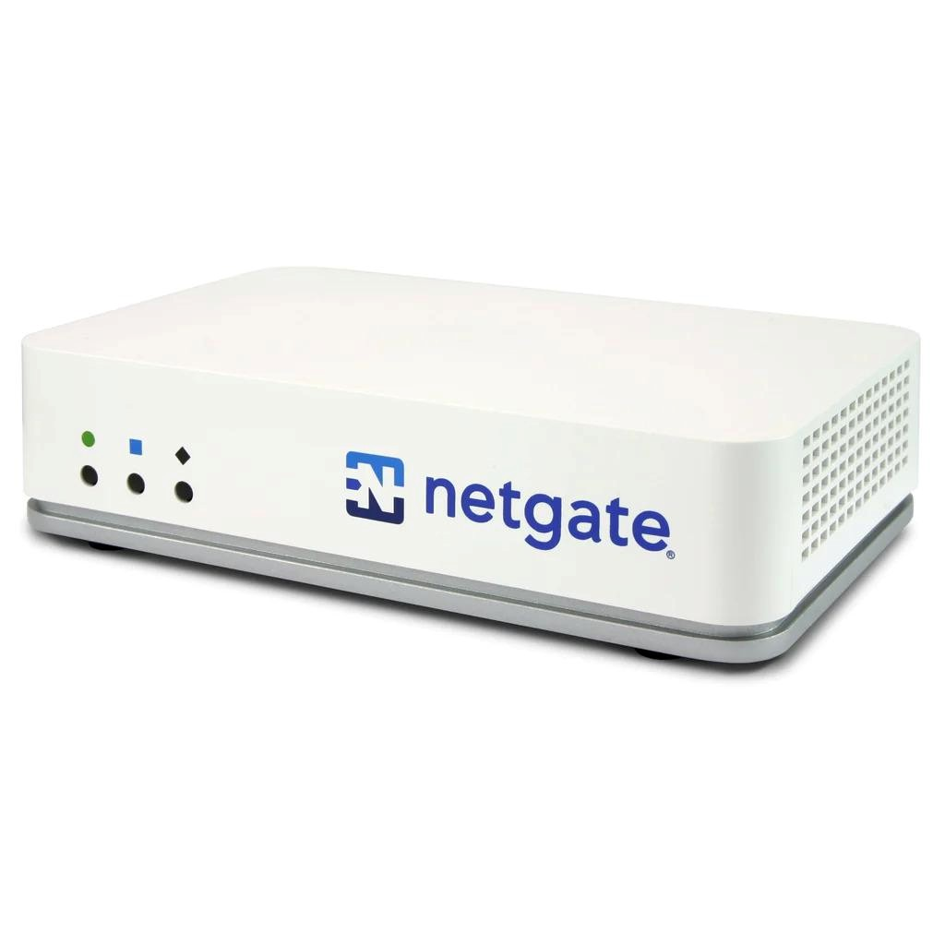  Netgate 2100 MAX pfSense +Security  Gateway | 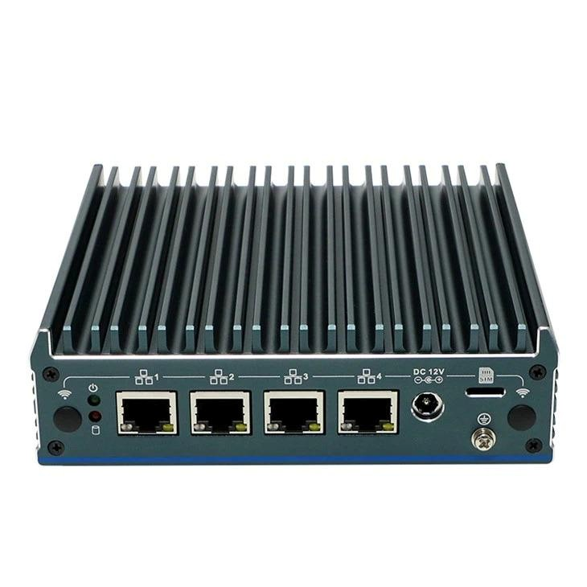  N100 Firewall Router | 1U Rack Mount Firewall Appliance
-The Dual core ARM v8  Cortex-A53 1.2 GHz delivers 2.20 Gbps routing for common iPerf3 traffic and over 964 Mbps of firewall throughput.  - Flexible 5-port combination including (1) 4-Port 1 GbE Marvell switch and a dedicated  (1) GbE WAN RJ45/SFP combo port.  -8 GB eMMC Flash onboard  (or optional 128 GB M.2 SATA 2242 SSD)  - 4 GB DDR4, DDR4 memory allows more stable, higher transfer rates for  memory-intensive applications (e.g. IDS/IPS).  - The passive cooling system and low power draw of the Netgate 2100 provides efficient thermal management and silent operation expected from smaller devices despite its significantly higher performance. | -Powered by a quad-core ARM Cortex-A53 processor for efficient performance and secure routing.  -Equipped with 3 Gigabit Ethernet ports, allowing flexible WAN/LAN configurations for small networks.  -Includes 2 GB DDR4 RAM and 8 GB eMMC storage for  reliable operation and advanced configurations. -Supports features like VPN, VLANs, and advanced firewall capabilities, ensuring strong network security.  -Compact, fanless design with low power consumption, offering silent operation and energy efficiency. | -Powered by an Intel Quad-Core processor for high-performance routing and firewall operations.  -Features up to 6 Gigabit Ethernet ports for versatile and scalable network configurations.  -Supports up to 8 GB DDR4 RAM, ensuring smooth  operation for  resource-intensive tasks like IDS/IPS and VPN services.  -Includes storage options like SSD or HDD, providing  flexibility for logs, backups, and configurations.  -Designed in a 1U rack-mountable form factor, perfect for data centers and enterprise environments requiring compact, organized setups.  -Advanced cooling system ensures reliable thermal
 |  | management and consistent performance under heavy workloads.
RM 1750 | RM 1500 | RM 1200

We selected the 1U Rack Mount Firewall Appliance as it offers the most powerful and flexible solution, making it highly suitable for professional environments and high-budget network infrastructures. Equipped with a robust Intel Quad-Core processor and supporting up to 8 GB of memory, it is capable of efficiently managing resource-intensive tasks such as network security and private connections. The device includes six Ethernet ports and supports various storage configurations, allowing it to adapt seamlessly to complex network requirements. Its rack-mountable design ensures easy integration into professional setups, while the advanced cooling system maintains optimal performance even under heavy workloads. These features make it a reliable and scalable choice for large networks and data center applications.
12-Modems:
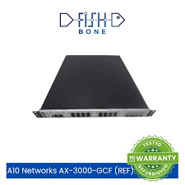  A10 Networks  AX-3000-GCF  Application Delivery  Controllers (REF) | Nighthawk®Mid/high-Split  Multi-Gig 2.5Gbps Cable Modem | 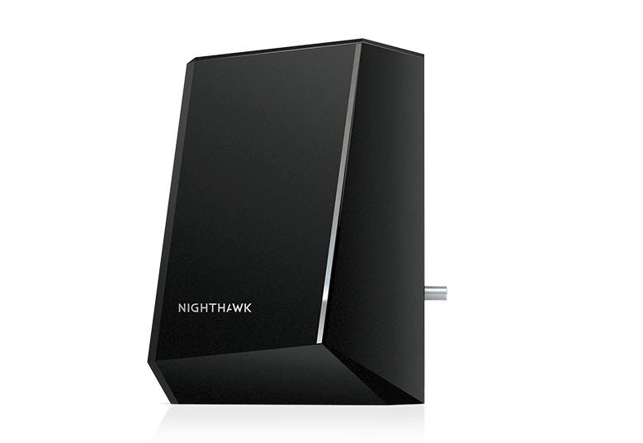  Nighthawk® Multi-Gig 2.5Gbps Cable Modem for Xfinity Voice
-Powered by advanced multi-core processors, delivering high-performance application delivery and load balancing.  -Supports up to 8 Gigabit Ethernet ports, enabling robust and scalable network integration.  -Provides up to 15 Gbps of application throughput for seamless traffic management in demanding environments. -Features advanced Layer 4-7 traffic management | -Supports 2.5Gbps multi-gig speeds, designed for ultra-fast internet connectivity with mid/high-split compatibility.  -Certified for major ISPs, including Xfinity, Spectrum, and Cox, ensuring wide compatibility.  -Features DOCSIS 3.1 technology, offering 32x8 channel bonding for reliable | -Supports 2.5Gbps multi-gig internet speeds, ideal for high-performance home and office networks.  -Certified for Xfinity Voice with support for up to two phone  lines for reliable digital voice service.  -Powered by DOCSIS 3.1 technology, offering 32x8 channel bonding for ultra-fast and stable connectivity.
capabilities for optimized application performance and security.  -Includes hardware SSL acceleration for efficient and secure encrypted traffic handling. -Designed for  enterprise-grade reliability with a rack-mountable 1U form factor, suitable for data centers and large-scale deployments. | high-speed performance.  -Includes a multi-gig Ethernet port, enabling seamless integration with high-speed routers and devices.  -Compact, sleek design with efficient cooling for stable and consistent operation.  -Ideal for future-proofing home or office networks with support for high-bandwidth applications like 4K streaming and gaming. | -Features a multi-gig Ethernet port, enabling seamless integration with high-speed routers and devices.  -Compact, modern design with efficient cooling for consistent operation.  -Perfect for streaming, gaming, and voice services, ensuring a future-proof network setup.
RM 1800 | RM 1300 | RM 1100

For our network project, we selected the Nighthawk® Mid/High-Split Multi-Gig 2.5Gbps Cable Modem due to its ability to deliver exceptionally fast internet speeds, which are crucial for ensuring seamless connectivity across our devices. With a maximum speed of up to 2.5Gbps, the modem is well-suited for handling high-bandwidth activities such as video streaming and online gaming, without experiencing performance degradation.

An important advantage is its compatibility with major internet service providers, which simplifies the setup process and enhances its overall reliability. Additionally, the modem features a sleek and compact design, making it ideal for space-saving installations, and its efficient cooling system helps maintain stable and consistent performance by preventing overheating.

In conclusion, the Nighthawk® modem offers the speed, reliability, and future scalability required for our project, making it the most suitable choice for our networking needs.

13- Wireless Access Point:
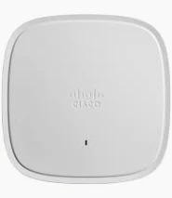  Cisco Access Point  AIR-AP1832I-K-K9  (Refurbished) | TP-Link EAP653 AX3000 | 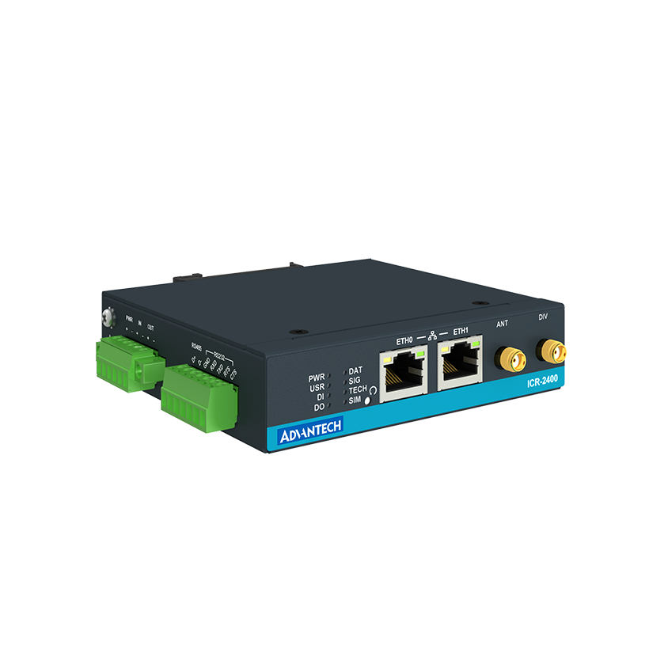  ICR-2431
-Features 802.11ac Wave 2 technology, delivering high-speed Wi-Fi performance with data rates up to 1.3 Gbps. -Equipped with 3x3 MU-MIMO  (Multi-User, Multiple Input, Multiple Output) for efficient device connectivity and enhanced user experience. -Supports dual-band operation (2.4 GHz and 5 GHz) for flexible deployment and reduced interference.  -Includes beamforming technology to optimize wireless signal strength and coverage.  -Designed with integrated security features, such as WPA3 and rogue device  detection, ensuring reliable and secure network access. -Compact and durable design, ideal for medium to large-scale indoor deployments like offices and classrooms.  . | -Supports Wi-Fi 6 (802.11ax) technology, offering ultra-fast speeds of up to 2976 Mbps (2402 Mbps on 5 GHz and 574 Mbps on 2.4 GHz).  -Features MU-MIMO and  OFDMA to handle multiple  devices efficiently, reducing latency and boosting overall network performance. -Equipped with seamless roaming to ensure uninterrupted connectivity as users move across the network.  -Includes Power over Ethernet (PoE+) support, simplifying deployment and reducing cable clutter. -Offers advanced security protocols, including WPA3, to safeguard user data and enhance network protection. -Compact, sleek design suitable for ceiling or wall mounting, ideal for offices, schools, and hospitality environments. | -Powered by an advanced  processor, offering reliable performance for industrial and IoT applications.  Supports dual SIM failover  and multiple WAN options  (Ethernet, LTE) for uninterrupted connectivity. -Features Gigabit Ethernet ports, serial interfaces, and digital I/Os for versatile integration with various devices and systems. Includes robust security features like VPN, firewall, and encryption to protect data and ensure secure communication. -Designed for rugged environments with a compact, durable enclosure and wide operating temperature range.  -Supports remote management and monitoring through intuitive software, ideal for industrial automation, transportation, and smart city deployments.
RM 1400 | RM 580 | RM 1300

We chose the TP-Link EAP653 AX3000 due to its integration of the latest Wi-Fi 6 technology, which enables high-speed performance of up to 2976 Mbps. This capability is particularly beneficial for our network environment, as it supports multiple simultaneous connections without compromising speed or stability.
The EAP653 also facilitates seamless mobility, allowing users to move freely across spaces—such as offices or classrooms—without experiencing connectivity loss. Furthermore, its support for Power over Ethernet (PoE) simplifies installation by requiring only a single cable for both power and data transmission.
In addition to performance and ease of deployment, the device includes robust security features to help protect sensitive data. Its compact and unobtrusive design makes it suitable for installation in a variety of locations.
Overall, the TP-Link EAP653 AX3000 offers an optimal balance of speed, flexibility, and security, making it the most appropriate choice for our network requirements.
14-Patch Panel:
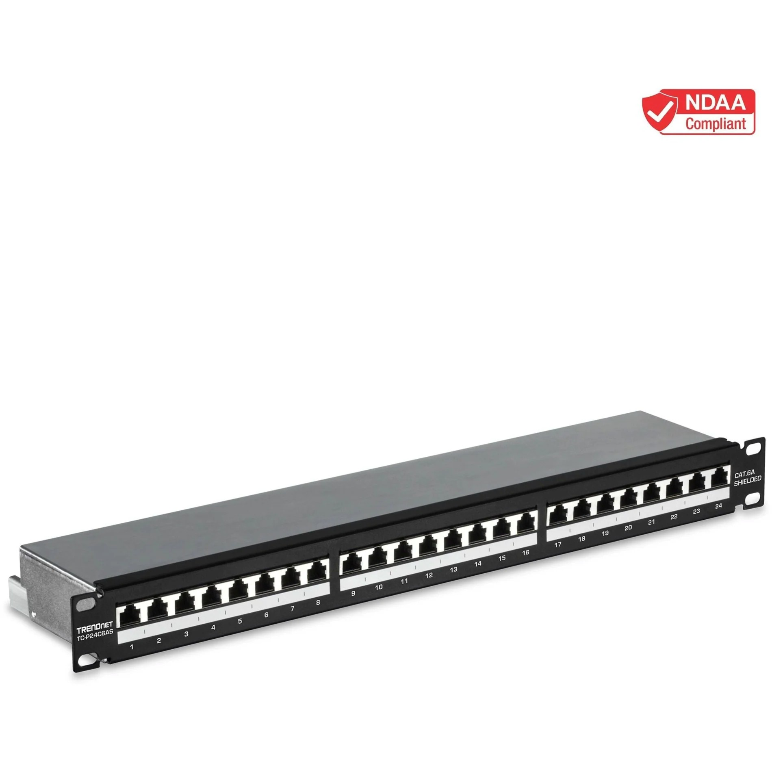  TRENDnet 24-Port Cat6A  Shielded Patch Panel | 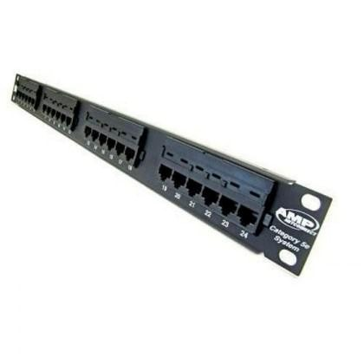  Commscope AMP Cat6  Category 6 System 24 Port Patch Panel | ICC Patch Panel, CAT 6A, 48-Port, 2 RMS (ICMPP0486B)
-Supports 24 shielded RJ45 ports, designed for high-performance Cat6A Ethernet connections. Provides 10 Gigabit Ethernet support, ensuring reliable, high-speed data transmission for demanding networks. -Features a shielded design to reduce electromagnetic interference (EMI) and maintain signal integrity.  -Includes numbered ports and a labeling area for easy cable identification and management.  -Durable metal housing offers long-lasting performance and reliability in rack-mount installations.  -Ideal for professional environments like data centers, server rooms, and structured cabling projects.  . | -Features 24 RJ45 ports, designed for efficient cable management in Cat6 Ethernet networks.  -Supports 10 Gigabit Ethernet, delivering high-speed and reliable performance for demanding applications. Includes a color-coded wiring label for easy installation and reduced setup errors. -Built with durable construction for long-lasting performance in professional environments. -Designed for seamless integration into standard 19-inch rack systems, ensuring a neat and organized setup.  Ideal for structured cabling solutions in offices, data centers, and enterprise networks. | -Equipped with 48 RJ45 ports, supporting high-performance Cat6A Ethernet connections.  Certified for 10 Gigabit Ethernet, ensuring reliable and fast data transmission. -Features a 2U rack-mount design, fitting seamlessly into standard 19-inch racks for organized installations. -Includes color-coded labels for T568A and T568B wiring configurations, simplifying setup and maintenance.  -Built with a durable metal  frame, providing long-lasting performance in demanding environments. -Perfect for large-scale structured cabling projects in data centers, server rooms, and enterprise networks.
RM 460 | RM 580 | RM 1700

We selected the ICC Patch Panel, CAT 6A, 48-Port, 2 RMS as it offers the most suitable solution for our high-budget network project. With 48 ports, it allows for the simultaneous connection of a large number of devices, making it ideal for extensive network infrastructures. Its support for 10 Gigabit Ethernet ensures high-speed and reliable data transmission, which is essential for demanding applications.
The 2U rack-mount design facilitates easy integration into standard server racks, helping maintain a neat and organized setup. Additionally, the presence of color-coded labels simplifies the wiring process and reduces installation time by providing clear guidance.
Constructed from durable materials, this patch panel is built to withstand the demands of high-traffic environments, offering both longevity and stability. Overall, it delivers the performance, scalability, and efficiency required for the success of our network deployment.

Meeting Minutes 1
Date/Time | 8 May 2025 9:00pm
Location | Online (google meet)
Agenda | Task distribution for task 3
Meeting MC | Garrah Thabit Mohammed
Attendance
Name |  | Time | Reason For Absence
Garrah Thabit Mohammed |  | 9:00 pm | -
Mohammed Abdulrahim |  | 9:00 pm | -
LEE TUNG ERN |  | 9:00 pm | -
MOHAMMED ALSAKKAF |  | 9:00 pm | -
Minutes
No. | Items Discussed | Ideas/Suggestions and  Person Giving It | Person in Charge &  Date

1. | The devices (network and end-user devices) that will need to achieve the objective of fulfilling the requirements and needs of the organization | Each group member contributed their input regarding the essential devices required for the organization. In total, 14 different types of devices were identified to meet the operational needs. Garrah emphasized the importance of printers, copiers, smart TVs, desktop towers, and monitors for the effective functioning of faculty activities. Mohammed highlighted the necessity of routers, switches, servers, Ethernet cables, and fiber optic cables to support network infrastructure. Meanwhile, Lee Tung pointed out that firewalls, modems, wireless access points, and patch panels are also essential for ensuring secure and reliable connectivity. | - GARRAH  - MOHAMMED  - LEE TUNG
2. | Task Distribution | Garrah volunteered to conduct research on printers, copiers, smart TVs, desktop towers, and monitors. | GARRAH
2. | Task Distribution | Mohammed took on the task of researching routers, switches, servers, and network cabling. | MOHAMMED

 |  | LEE TUNG volunteered to do research on firewalls, modems, wireless access points, and patch panels | LEE TUNG
3. | Record of the discussion | Recorded all the devices needed and send it to the group | GARRAH
3. | Record of the discussion | Documented which group member was responsible for researching each device. | ALSAKKAF
4. | Decide next discussion (meeting) | we agreed to hold a meeting on 12 May 2025 at 8:00 PM to discuss and finalize the quantity of each device required, based on both the pricing information gathered during our research and the overall budget available. | All members
5. | Meeting ended | Meeting ended at10:30 pm. | -

Meeting Minutes 2
Date/Time | 12 May2025 - 8:00pm
Location | Online (google meet)
Agenda | Discuss about the quantity of devices base on budget
Meeting MC | GARRAH
Attendance
Name |  | Time | Reason For Absence
Garrah Thabit Mohammed |  | 8:00 pm | -
Mohammed Abdulrahim |  | 8:00 pm | -
LEE TUNG ERN |  | 8:30 pm | -
MOHAMMED ALSAKKAF |  | 9:00 pm | -
Minutes
No. | Items Discussed | Ideas/Suggestions and  Person Giving It | Person in Charge &  Date
1. | The result of researching | Everyone has shown the results of their research on the assigned devices, including descriptions and prices, in a table created by Othman. Each type of device was required to be sourced from 3 different brands for comparison. | All members
2. | Decide the amount of devices needed | After each member fills in the table, we will start deciding the quantities needed and | All members

 |  | choose the best devices based on our budget, one by one, following the table.
3. | Reflections | For the reflection on Question 3, we summarized our individual opinions following a group discussion and recorded them in a shared Google Document, providing justifications for each device choice. | All members
4. |  | Once the discussion was complete and final decisions were made, each group member was assigned specific tasks to complete their part of the work promptly. | All members
5. | Meeting Ended | Meeting ended at  11.30pm | -

References
1A.Printer (HP OfficeJet Pro 8120 All-in-One Printer)
HP OfficeJet Pro 8120 All-in-One Printer - (405W3C) - Shop HP.com Malaysia
1B.Printer(Canon Pixma E410 All-In-One Printer)
Printing - PIXMA E410 (Green White) - Specification - Canon Malaysia
1C.Printer(Brother A4 + A3 Ink Tank MFC-J2340DW)
MFC-J2340DW – Brother Malaysia
2A.Copier(HP LaserJet M635fht Laser Multifunction Printer-Monochrome-Copier)
HP LaserJet M635 M635fht Laser Multifunction Printer-Monochrome-Copier – Network Hardwares
2B.Copier(Kyocera TASKalfa 2554ci Printer)
Kyocera TASKalfa 2554ci Printer, Up to 1200 x 1200 DPI Resolution, Up to 100 IPM Simplex/200 IPM Duplex Scan Speed, 25 PPM B&W/25 PPM Color Engine Speed | 1102YP3NL0 Buy, Best Price. Global Shipping.
2C.Copier(Brother MFC L9610CDN Color Laser All-in-One Copier)
Brother MFCL9610CDN MFC-L9610CDN Enterprise Color Laser All-in-One Pri – Network Hardwares
3A.Smart TV(PRISM+ Q75 Ultra)
PRISM+ Q75 Ultra – PRISM+ Malaysia
3B..Smart TV(Philips 7100 Series 75-inch 4K UHD LED TV)
Philips 7100 Series 75-inch 4K UHD LED 2024 Google TV - Black (75PUT7129/68) | Harvey Norman Malaysia
7100 series 4K UHD LED TV 75PUT7129/68 | Philips
3C..Smart TV(SAMSUNG 75" Crystal UHD DUE800 4K Smart TV)
Buy 75 Inch Crystal UHD DUE800 4K Tizen OS Smart TV | Samsung MY
4A. Router (ASUS RT-AX58U) ASUS RT-AX88U Pro
4B. Router (Netgear RAX50) Netgear RAX50
4C. Router (TP-Link Archer AX75)
TP-Link Archer AX75
5A. Switch (TP-Link TL-SG2428P) TP-Link TL-SG2428P
5B. Switch (MikroTik CRS326-24G-2S+RM)
CRS326-24G-2S+RM
5C. Switch (Aruba Instant On 1930 48G 4SFP/SFP Switch JL685A) Aruba Instant On 1930 48G 4SFP/SFP Switch JL685A
6A.Desktop(HP Pro Tower 400 G9 PCI Desktop PC)
HP Pro Tower 400 G9 PCI Desktop PC - (A3MK8PT) - Shop HP.com Malaysia
6B.Desktop(DELL OptiPlex Small Form Factor)
Dell OptiPlex Small Form Factor Desktop | Dell Malaysia
6C.Desktop(Acer Consumer Desktop | Aspire XC Series - XC-1785)
Acer Consumer Desktop | Aspire XC Series - XC-1785-14400W11B, Intel® Core™ i5 14400 | Acer Malaysia Official Store
7A.Monitor(Acer Monitor - Mainstream Series - Work & Play| EK221Q H)
Acer Monitor - Mainstream Series - Work & Play| EK221Q H | Acer Malaysia Official Store
7B.Monitor(SAMSUNG 24" Essential Monitor S3 S31C FHD)
24" Essential Monitor S3 S31C FHD LS24C310EAEXXS | Samsung Malaysia
7C.Monitor(PRISM+ W220v)
PRISM+ W220v - Productivity Monitor – PRISM+ Malaysia
8A. Server (PowerEdge R250 Rack Server)
PowerEdge R250 Rack Server
8B. Server (HPE ProLiant DL20 Gen11 Rack Server (E-2434.16GB.1TB) HPE ProLiant DL20 Gen11 Rack Server (E-2434.16GB.1TB)
8C. Server (Lenovo ThinkSystem ST250 V2 7D8FS0Y400) Lenovo ThinkSystem ST250 V2 7D8FS0Y400
9A. Ethernet Cable (cat 6a (2996AS-5G) by Videk) cat 6a (2996AS-5G) by Videk
9B. Ethernet Cable (cat 6a (21.15.2709) by Roline) cat 6a (21.15.2709) by Roline
9C. Ethernet Cable (cat 6a (N261P-050-BL) by EATON TRIPP LITE) cat 6a (N261P-050-BL) by EATON TRIPP LITE
10A. Fiber Optic (HFBR-RUS100Z) by BROADCOM Fiber Optic (HFBR-RUS100Z) by BROADCOM
10B. Fiber Optic (FDPF 4001 EH) by FIBRE DATA
Fiber Optic (FDPF 4001 EH) by FIBRE DATA
10C. Fiber Optic Cable (Fiber Optic (MP007797) by MULTICOMP PRO)
Fiber Optic Cable (Fiber Optic (MP007797) by MULTICOMP PRO)
11.A. Firewall (Netgate 2100 MAX pfSense+ Security Gateway) https://shop.netgate.com/products/2100-max-pfsense
11.B Firewall (N100 Firewall Router)
https://www.iwillminipc.com/network-security/firewall-micro-appliance/n100-firewall-router.html?_gl=
1*1pn3wle*_up*MQ..*_gs*MQ..&gclid=CjwKCAiAjKu6BhAMEiwAx4UsAo13_uF0ttIOB2nnYFXQ xv9-QR2qSEOoyXhIflCh4enDHA7OFAU4QRoCnkQQAvD_BwE
11.C FireWall (1U Rack Mount Firewall Appliance)
https://www.iwillminipc.com/network-security/1u-rackmount-network-server/1u-rack-mount-firewall-a
ppliance.html?_gl=1*1cd376p*_up*MQ..*_gs*MQ..&gclid=CjwKCAiAjKu6BhAMEiwAx4UsAjxkQ ThSqEGlV6TYH73fMeFmGmPweocgUl3i6GO5OFmGWSyP9XKHpBoCWtYQAvD_BwE
12.A.Modem (A10 Networks AX-3000-GCF Application Delivery Controllers (REF)) https://fishbone.com.my/a10-networks-ax-3000-gcf-ref?gad_source=1&gclid=CjwKCAiAjKu6BhAME iwAx4UsAqjSXxQIV_JP8SWYvk259KR28_YUDf9N0mnoysFTp-trH6jq3BP-oxoC91MQAvD_BwE
- B.Modem (Nighthawk® Mid/high-Split Multi-Gig 2.5Gbps Cable Modem) https://www.netgear.com/home/wifi/modems/cm3000/
12.C. Modem (Nighthawk® Multi-Gig 2.5Gbps Cable Modem for Xfinity Voice) https://www.netgear.com/home/wifi/modems/cm2050v/
- A.Wireless Access point (Cisco Access Point AIR-AP1832I-K-K9 (Refurbished)) https://fishbone.com.my/refurbished-cisco-access-point-air-ap1832i-k-k9?srsltid=AfmBOoq08iYeOCP2 jaWMvr05MRD4m0S49Ddrn6M1VHp1asHvIk0CrDsw
  - Wireless Access point (TP-Link EAP653 AX3000)
https://www.networkhardwares.com/en-my/products/tp-link-eap653-tp-link-ax3000-ceiling-mount-dualband-wi-fi-6-access-point-eap653?variant=41654228123853&utm_source=google-ads&utm_campaign =&utm_agid=&utm_term=&creative=&device=c&placement=&gad_source=1&gclid=CjwKCAiAjKu6
BhAMEiwAx4UsAjbkw0TEehPwnT_ac9y0k_5h7DYQCP2qcoypaUUl4JVzncVmtS9cgxoCnSAQAvD _BwE
  - Wireless Access point (ICR-2431) https://www.iotmart.com/en-en/s/product/detail/01t2y000000czAQAAY?language=en_US&gad_source=1&gclid =CjwKCAiAjKu6BhAMEiwAx4UsAn2nNoblN3h0QtIiBIq8_2bb9IUOYZ2qFZYkvjOtX9ihA1NAvcHG-xoCy2 4QAvD_BwE
  - Patch Panel (TRENDnet 24-Port Cat6A Shielded Patch Panel)
https://www.networkhardwares.com/en-my/products/trendnet-tc-p24c6as-trendnet-24-port-cat6a-patch-panel-shie lded-tc-p24c6as?variant=47557555978445&utm_source=google-ads&utm_campaign=&utm_agid=&utm_term= &creative=&device=c&placement=&gad_source=1&gclid=CjwKCAiAjKu6BhAMEiwAx4UsAlgGKtVseXP8vu Oi_ia0RsiHAirNiOW-tvPiaKPOBANFSYEakx83UBoCvz8QAvD_BwE
  - Patch Panel (Commscope AMP Cat6 Category 6 System 24 Port Patch Panel) https://www.sysnapse.com/commscope-amp-cat6-category-6-system-24-port-patch-panel?gad_source=1
&gclid=CjwKCAiAjKu6BhAMEiwAx4UsAul9LVApdQJuW6UBuAcUvBNkfDNx5QvEFRs7890rhxm iFLbNfwtBBRoCLEEQAvD_BwE
  - Patch Panel (ICC Patch Panel, CAT 6A, 48-Port, 2 RMS (ICMPP0486B))
https://www.networkhardwares.com/en-my/products/icc-icmpp0486b-icc-patch-panel-cat-6a-48-port-2-r ms-icmpp0486b?variant=47992374493389&utm_source=google-ads&utm_campaign=&utm_agid=&ut m_term=&creative=&device=c&placement=&gad_source=1&gclid=CjwKCAiAjKu6BhAMEiwAx4Us
AuB8rcGXtePc0yR3BiIawRtLQ3frq1hocXcRuQuDc8qAwgJ0dyaPcRoCluAQAvD_BwE

